The Mathematics of Deep Learning

Deep learning is a subfield of Machine Learning Science which is based on artificial neural networks. It has several derivatives such as Multi-Layer Perceptron (MLP), Convolutional Neural Networks (CNN) and Recurrent Neural Networks (RNN) which can be applied to many fields including Computer Vision, Natural Language Processing, Machine Translation…

Deep learning is taking off for three main reasons:

* **Automated features engineering**: while most of machine learning algorithms require human expertise for the feature engineering and extraction, deep learning handles automatically the choice of variables and their weights
* **Huge Datasets**: the continuous collection of data has led to large databases which allow deeper neural networks
* **Hardware evolution**: the new GPUs, for Graphical Process Units, allow faster algebraic calculation which is the core base of DL

In this chapter, we will focus mainly on the Multi-Layer Perceptron (MLP) where we will detail the mathematical background behind the success of deep learning and explore the optimization algorithms used to improve its performances.

The summary is as follows:

1. Definition
2. Learning algorithm
3. Parameter Initialization
4. Forward — Backpropagation
5. Activation functions
6. Optimization algorithm

**1- Definition**

**A neuron**

*In the context of deep learning a neuron is a block of mathematical operations linking entities together*

Let’s consider the problem where we estimate the price of a house based on its size, it can be represented as follows:

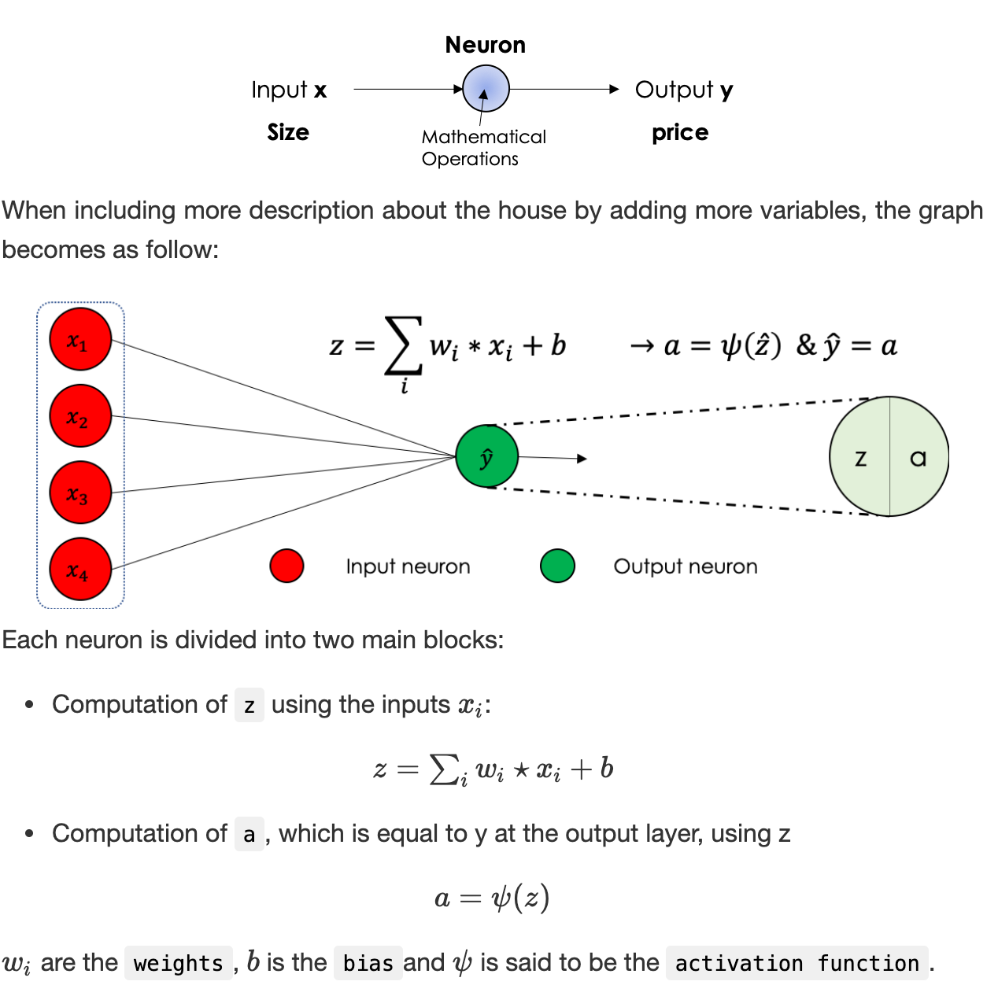

*In general, neural networks better known as MLP, for ‘Multi Layers Perceptron’, is a type of direct formal neural network organized into several layers in which information flows from the input layer to the output layer only.*

*Each layer consists of a defined number of neurons, we distinguish:*

*- The input layer*

*- The hidden layers*

*- The output layer*

The following graph represents a neural network with 5 neurons at the input, 3 in the first hidden layer, 3 in the second hidden layer and 2 out.

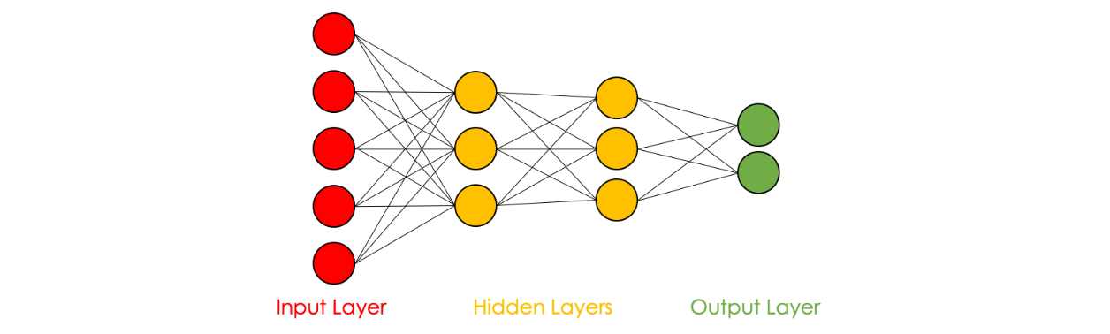

Some variables in the hidden layers can be interpreted based on the input features: in the case of the house pricing and under the assumption that the first neuron of the first hidden layer pays more attention to the variables *x_1*​ et *x_2*​, it can be interpreted as the quantification of the family size of the house for instance.

**DL as a supervised task**

In most DL problems, we tend to predict an output y using a set of variables X, in this case, we suppose that for each row of the database *X_i*​ we have the corresponding prediction *y_i*​, thus the labeled data.

**Applications**: Real Estate, Speech Recognition, Image Classification …

The used data can be:

* Structured: explicit databases with features well defined
* Unstructured: Audio, Image, Text, …

**Universal approximation theorem**

Deep learning in real life is the approximation of a given function *f*. This approximation is possible and accurate thanks to the following theorem:

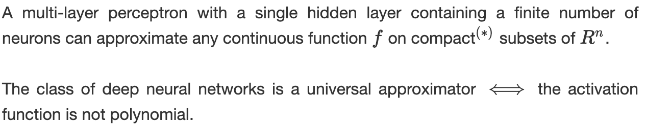

(*) In finite dimension, a set is said to be compact if it is closed and bounded. Visit this [link](https://en.wikipedia.org/wiki/Compact_space) for more details.  
The main take-away from this section is that deep learning allows solving any problem which can be mathematically expressed

**Data Preprocessing**

In any machine learning project in general, we divide our data into 3 sets:

***- Train set****: used to train the algorithm and construct batches*

***- Dev set****: used to finetune the algorithm and evaluate bias and variance*

***- Test set****: used to generalize the error/precision of the final algorithm*

The following table sums up the repartition of the three sets according to the size of the data set *m*:

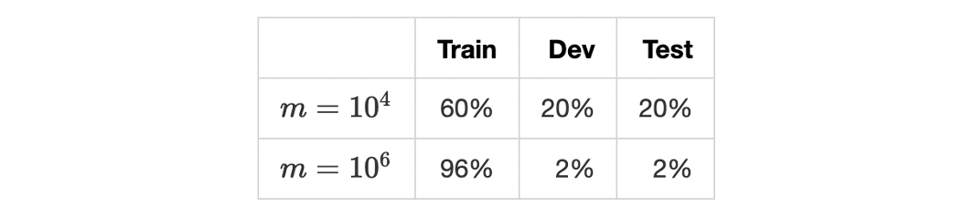

Standard deep learning algorithms require a large dataset where the number of samples is around lines. Now that the data is ready, we will see in the next section the training algorithm.  
Usually, before splitting the data, we also normalize the inputs, a step detailed later in this chapter.

**2. Learning algorithm**

Learning in neural networks is the step of calculating the weights of the parameters associated with the various regressions throughout the network. In other words, we aim to find the best parameters that give the best prediction/approximation, starting from the input, of the real value.  
For this, we define an objective function called the loss function and denoted J which quantifies the distance between the real and the predicted values on the overall training set.  
We minimize J following two major steps:

***- Forward Propagation****: we propagate the data through the network either in entirety or in batches, and we calculate the loss function on this batch which is nothing but the sum of the errors committed at the predicted output for the different rows.*

***- Backpropagation****: consists of calculating the gradients of the cost function with respect to the different parameters, then apply a descent algorithm to update them.*

We iterate the same process a number of times called epoch number. After defining the architecture, the learning algorithm is written as follows:

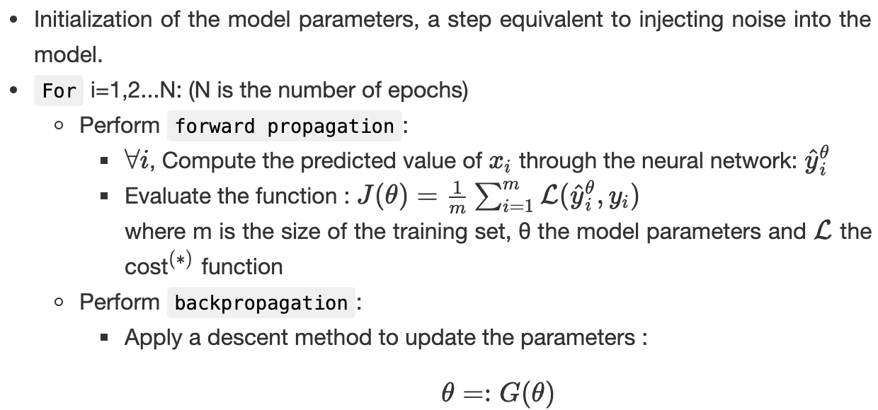

(∗) The cost function *L* evaluates the distances between the real and predicted value on a single point.

**3. Parameters’ initialization**

The first step after defining the architecture of the neural network is parameter initialization. It is equivalent to injecting initial noise into the model’s weights.

* **Zero initialization:**one can think of initializing the parameters with 0’s everywhere i.e: W=0 and b=0

Using the forward propagation equations, we note that all the hidden units will be symmetric which penalizes the learning phase.

* **Random initialization:**it’s an alternative commonly used and consists of injecting random noise in the parameters. If the noise is too large, some activation functions might get saturated which might later affect the computation of the gradient.

Two of the most famous initialization methods are:

* Xavier's: it consists of filling the parameters with values randomly sampled from a centered variable following the normal distribution:



* Glorot's: the same approach with a different variance:



**4. Forward and Backpropagation**

Before diving into the algebra behind deep learning, we will first set the annotation which will be used in expliciting the equations of both the forward and the backpropagation.

**Neural Network’s representation**

The neural network is a sequence of regressions followed by an activation function. They both define what we call the forward propagation. and are the **learned parameters** at each layer. The backpropagation is also a sequence of algebraic operations carried out from the output towards the input.

**Forward propagation**

* **Algebra through the network**

Let us consider a neural network having L layers as follows:

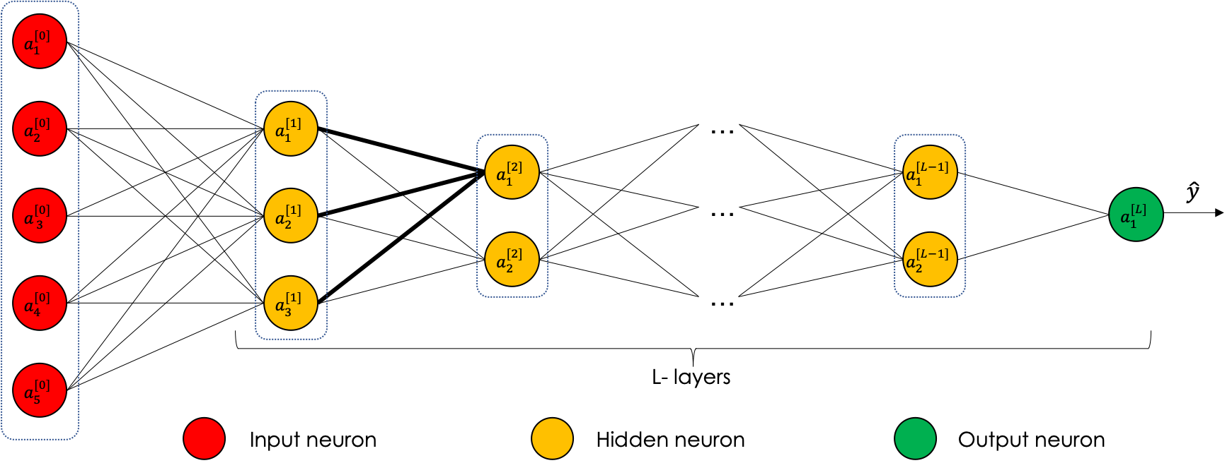

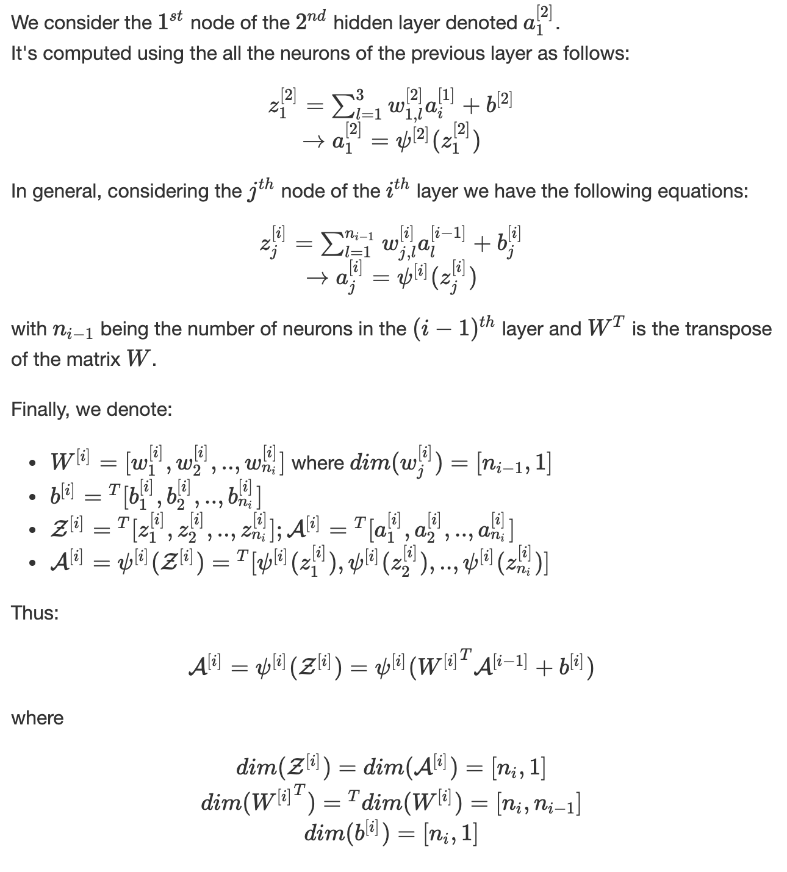

**Algebra through the training set**

Let us consider the prediction of the output of a single row data frame, through the neural network.

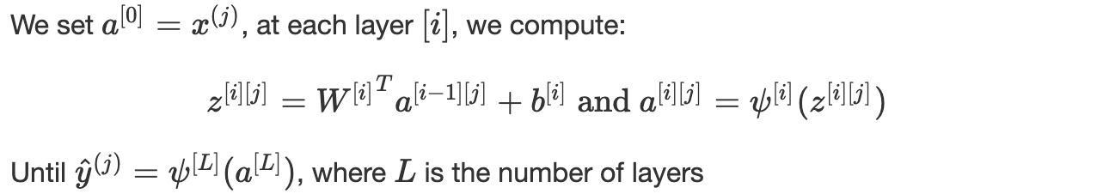

When dealing with a *m*-row data set, repeating these operations separately for each line is very costly.  
We have, at each layer [*i*]:

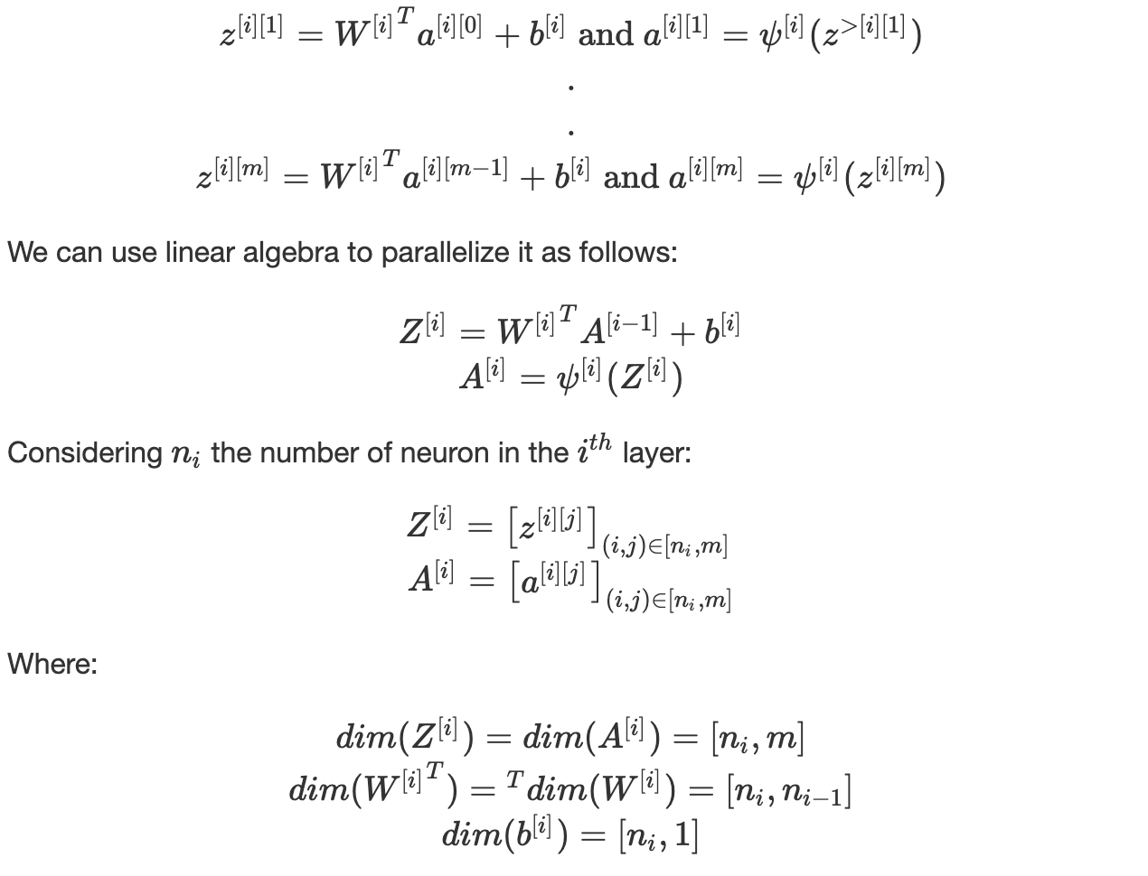

The parameter *b_i* uses broadcasting to repeat itself through the columns. This can be summarized in the following graph:

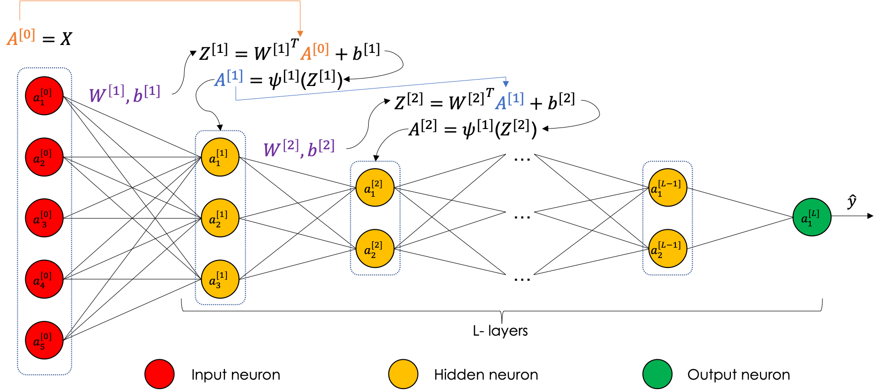

**Backpropagation**

The backpropagation is the second step of the learning, which consists of injecting the error committed in the prediction (forward) phase into the network and update its parameters to perform better on the next iteration.  
Hence, the optimization of the function *J*, usually through a descent method.

**Computational graph**

Most of the descent methods require the computation of the gradient of the loss function denoted ∇*J*(*θ*).

In a neural network, the operation is carried out using a computational graph which decomposes the function *J* into several intermediate variables.

Let us consider the following function: *f*(*x*,*y*,*z*)=(*x*+*y*).*z*

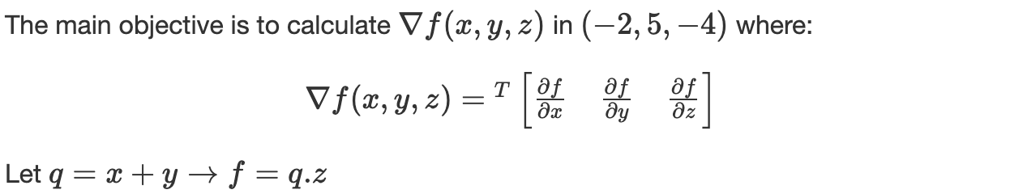

We carry out the computation using two passes:

* **Forward propagation**: computes the value of *f* from inputs to output: *f*(−2,5,−4)=−12
* **Backpropagation**: recursively apply chain-rule to compute gradients from output to inputs:

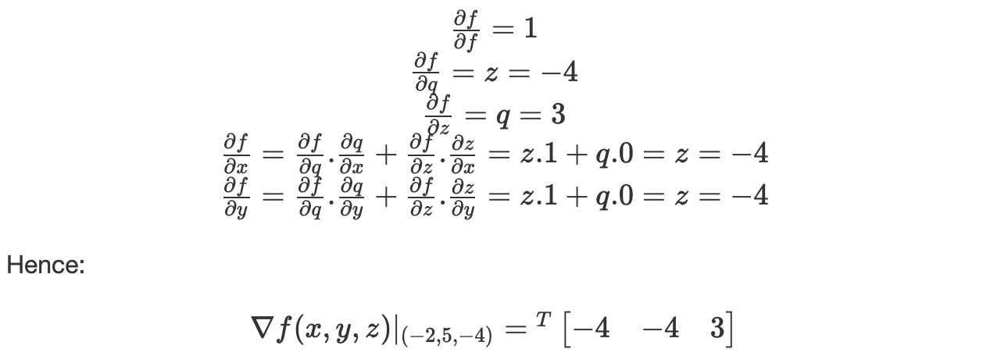

The derivatives can be resumed in the following *computational graph*:

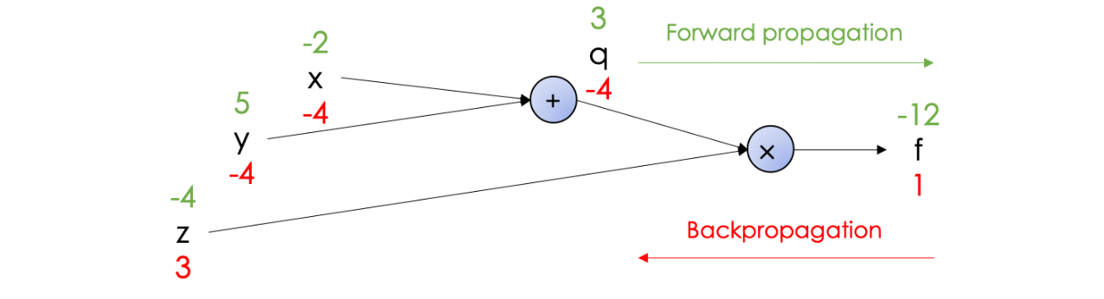

**Equations**

Mathematically, we compute the gradients of the cost function *J*, w.r.t the architecture’s parameters *W* and *b*.

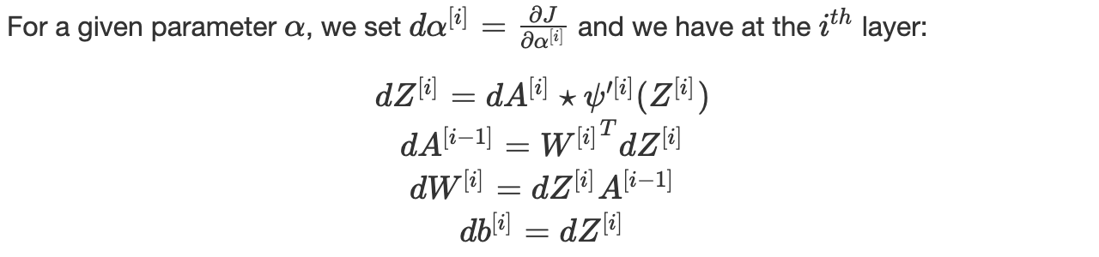

where (⋆) is the element-wise multiplication.  
We recursively apply these equations for *i*=*L*, *L*−1,…,1

**Gradient Checking**

When carrying out the backpropagation, an additional checking is added to make sure that the algebraic computations are correct.

Algorithm:

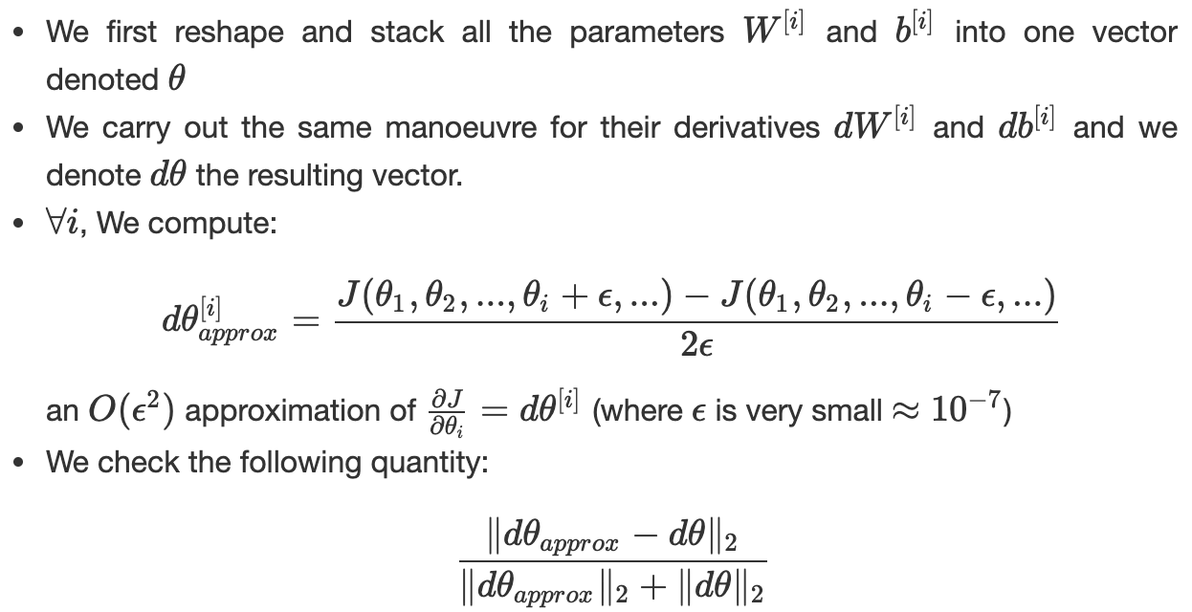

It should be close to the value of *ϵ*, an error is suspected when the value of the quantity is a *thousand* times higher than *ϵ.*

We can sum up the Forward and Backward propagation in the following block:

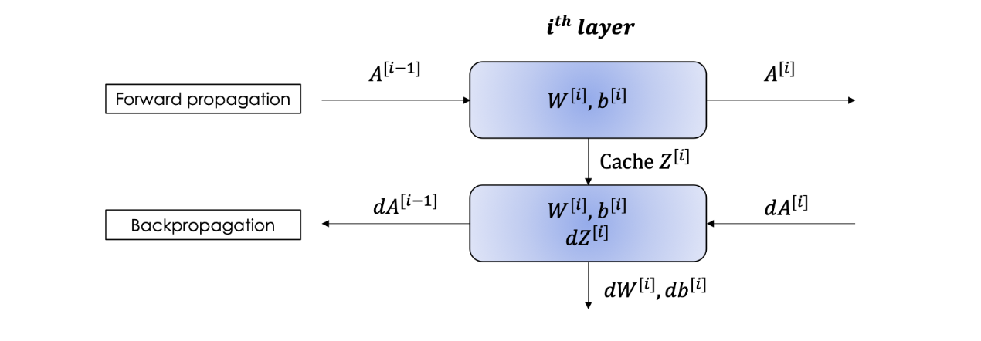

**Parameters vs Hyperparameters**

*-Parameters*, denoted *θ*, are the elements that we learn through the iterations and on which we apply backpropagation and update: *W* and *b.*

*-Hyperparameters* are all the other variables we define in our algorithm which can be *tuned* in order to improve the neural network:

* Learning rate *α*
* Number of iterations
* Choice of activation functions
* Number of layers *L*
* Number of units in each layer

**5. Activation functions**

Activation functions are a kind of transfer functions that select the data propagated in the neural network. The underlying interpretation is to allow a neuron in the network to propagate learning data (if it is in a learning phase) only if it is sufficiently excited.

Here is a list of the most common functions:

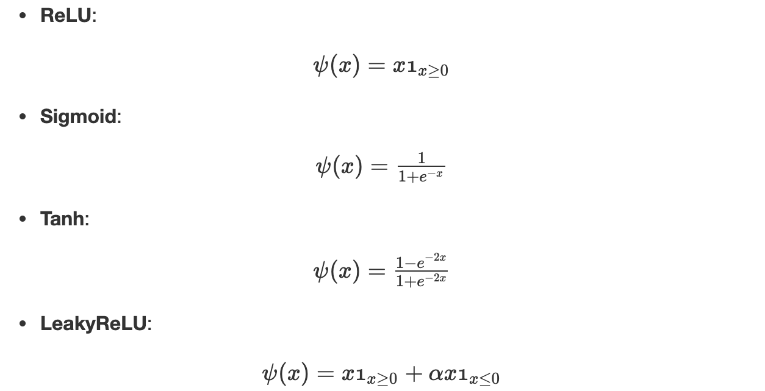

**Remark**: if the activation functions are all linear, the neural network is precisely equivalent to a simple linear regression

**6. Optimization algorithm**

**Risk**

Let us consider a neural network denoted by *f*. The real objective to optimize is defined as the expected loss over all the corpora:



Where *X* is an element from a continuous space of observables to which correspond a target *Y* and *p*(*X*,*Y*) being the marginal probability of observing the couple (*X*,*Y*).

**Empirical risk**

Since we cannot have all the corpora and hence we ignore the distribution, we restrict the estimation of the risk on a certain dataset well representative of the overall corpora and consider all the cases equiprobable.  
In this case: and where m is the size of the representative corpora. Hence, we iteratively optimize the loss function defined as follows:

Plus we can assert that:∫=∑ and *p*(*X*,*Y*)=1/m where m is the size of the representative corpora. Hence, we iteratively optimize the loss function defined as follows:



Plus we can assert that:



There exist many techniques and algorithms, mainly based on gradient descent, which carries out the optimization. In the sections below, we will go through the most famous ones. It is important to note that these algorithms might get stuck in local minima and nothing assures reaching the global one.

**Normalizing inputs**

Before optimizing the loss function, we need to normalize the inputs in order to speed up the learning. In this case, *J*(*θ*) becomes tighter and more symmetric which helps gradient descent to find the minimum faster and thus in fewer iterations.  
**Standard data** is the commonly used approach which consists of subtracting the mean of the variables and dividing by their standard deviation. Considering, the following image illustrates the effect of normalizing the input on the contour lines of -standard data on the right-:

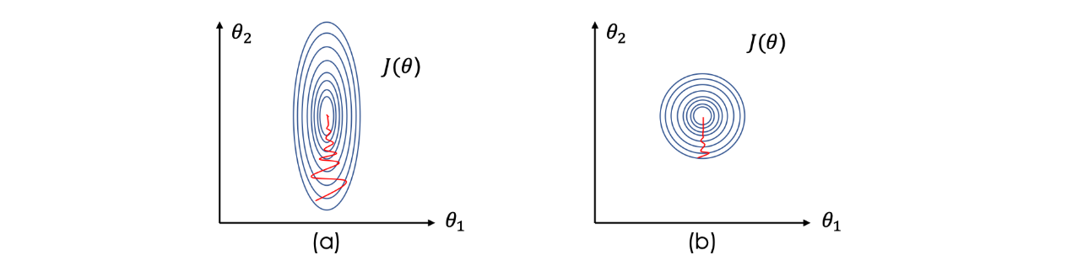

Let X be a variable in our database, we set:

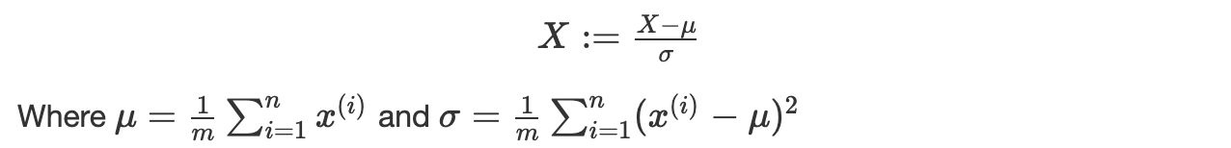

**Gradient descent**

In general, we tend to construct a convex and differentiable function *J* where any local minima is a global one. Mathematically speaking finding the global minimum of a convex function is equivalent to solving the equation ∇*J*(*θ*)=0, we denote *θ*⋆ its solution.  
Most of the used algorithms are of the kind:

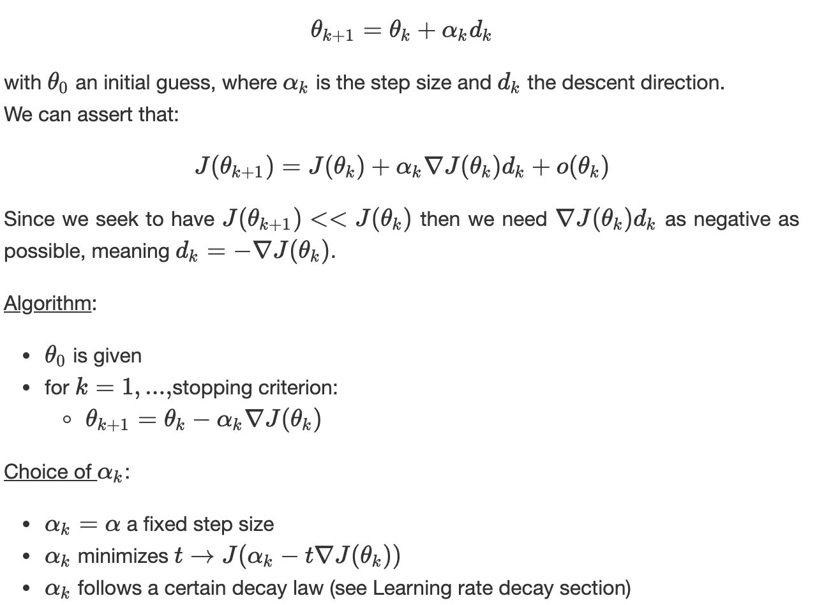

**Mini-batch gradient descent**

This technique consists of dividing the training set to batches:

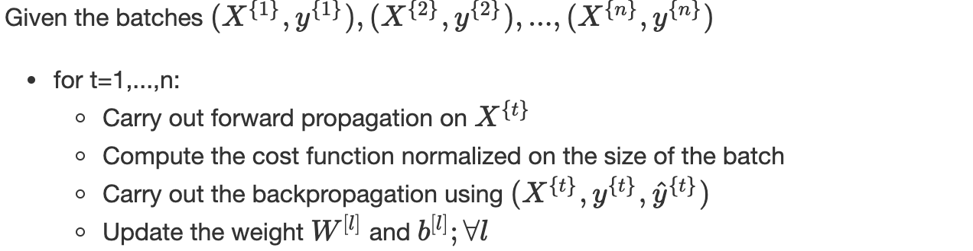

Choice of the mini-batch size:

* A small number of rows ∼2000 lines
* Typical size: the power of 2 which is good for memory
* Mini-batch should fit in CPU/GPU memory

Remark: in the case where there is only one data line in the batch, the algorithm is called stochastic gradient descent

**Gradient descent with momentum**

A variant of gradient descent which includes the notion of momentum, the algorithm is as follows:

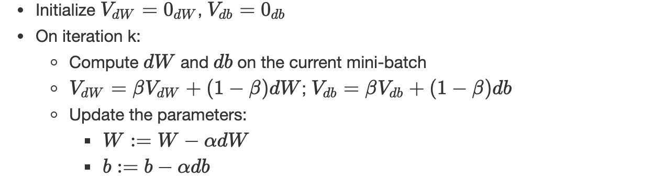

(*α*,*β*) are hyperparameters.  
Since *dθ* is calculated on a mini-batch, the resulting gradient ∇*J* is very noisy, this exponentially weighted averages included by the momentum give a better estimation of derivatives.

**RMSprop**

Root Mean Square prop is very similar to gradient descent with momentum, the only difference is that it includes the second-order momentum instead of the first-order one, plus a slight change on the parameters’ update:

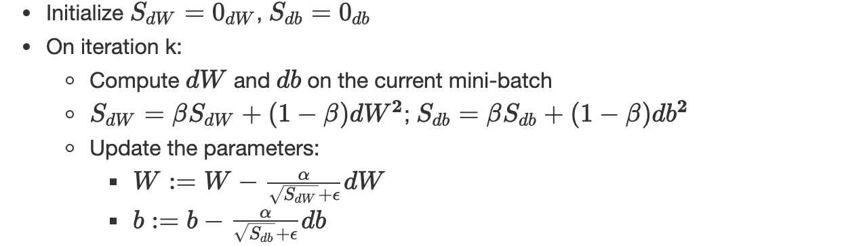

(*α*,*β*) are hyperparameters and *ϵ* assures numerical stability (≈10−8)

**Adam**

Adam is an adaptive learning rate optimization algorithm designed specifically for training deep neural networks. Adam can be seen as a combination of RMSprop and gradient descent with momentum.  
It uses square gradients to set the learning rate at scale as RMSprop and takes advantage of momentum by using the moving average of the gradient instead of the gradient itself as the gradient descends with momentum.  
The main idea is to avoid oscillations during optimization by accelerating the descent in the right direction.  
The algorithm of Adam optimizer is the following:

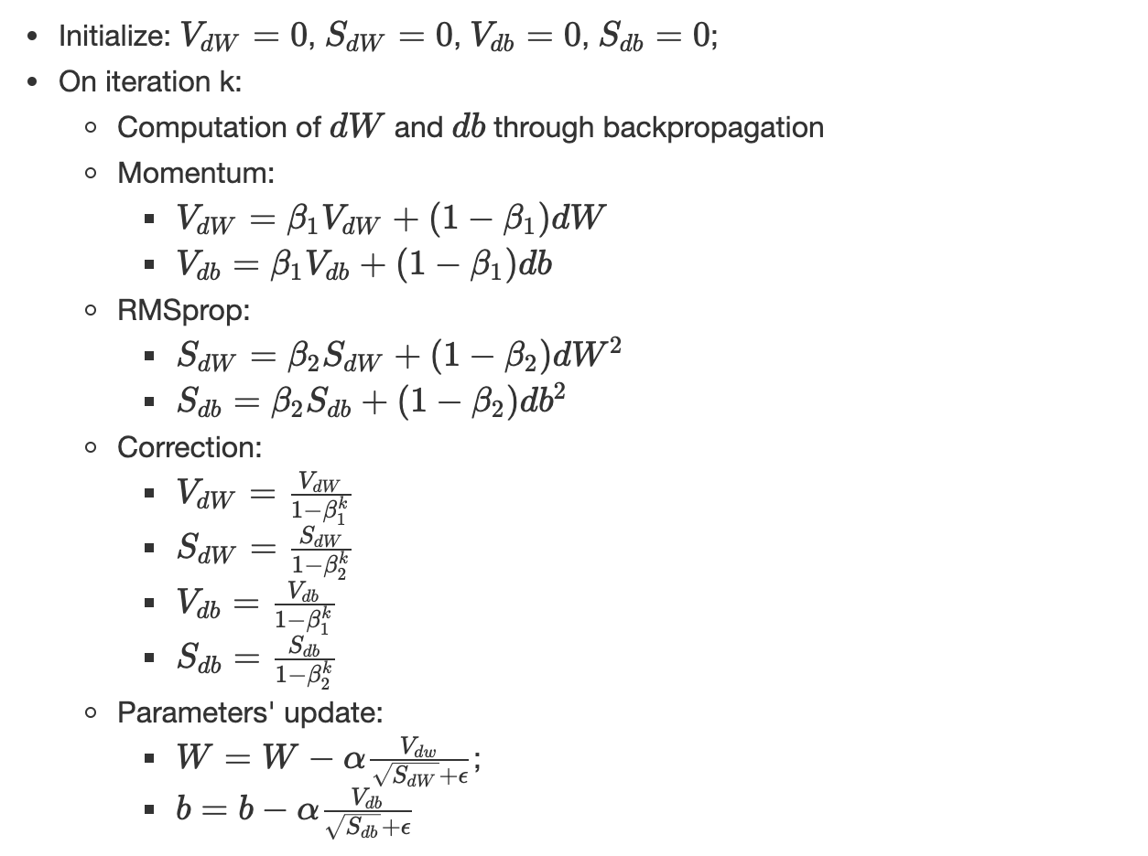

**Learning rate decay**

The main objective of the learning rate decay is to slowly reduce the learning rate over time/iterations. It finds justification in the fact that we afford to take big steps at the beginning of the learning but when approaching the global minimum, we slow down and thus decrease the learning rate.  
There exist many learning rate decay laws, here are some of the most common:

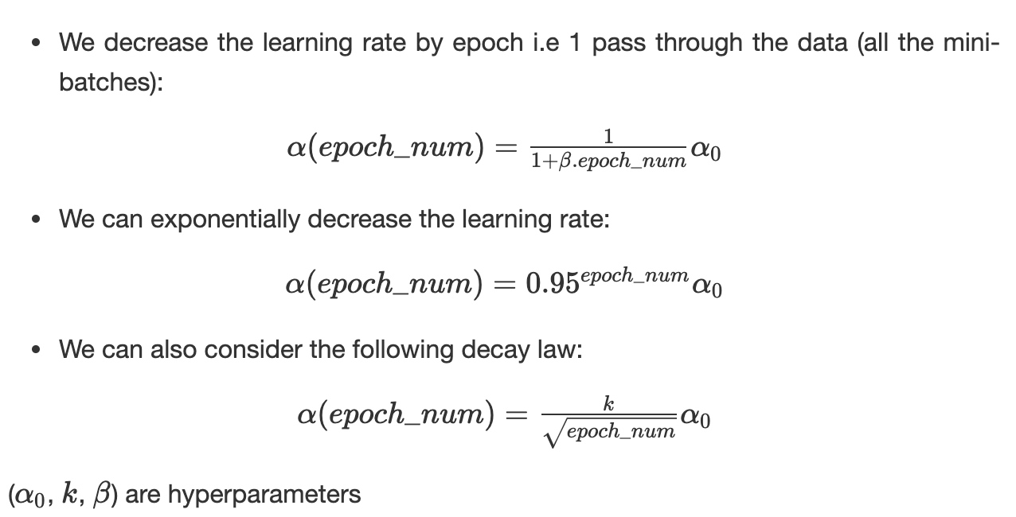

**Regularization**

**Variance/bias**

When training a neural network, it might suffer from:

* **High bias**: or underfitting, where the network fails to find the path in the data, in this case, *J_train*​ is very high the same as *J_dev*​. Mathematically speaking, when performing cross-validation; the mean of *J* on all the considered folds is high.
* **High variance** or overfitting, the model fits perfectly on the training data but fails to generalize on unseen data, in this case, *J_train*​ is very low and *J_dev*​ is relatively high. Mathematically speaking, when performing cross-validation; the variance of *J* on all the considered folds is high.

Let’s consider the dartboard game, where hitting the red target is the best-case scenario. Having a **low bias** (first line) means that **on average** we are close to the goal. In case, of a **low variance,** the hits are all concentrated around the target (the variance of the hits’ distribution is low). When the variance is high, under the assumption of a low bias, the hits are spread out but still around the red circle.  
Vice-versa, we can define the high bias with a low/high variance.

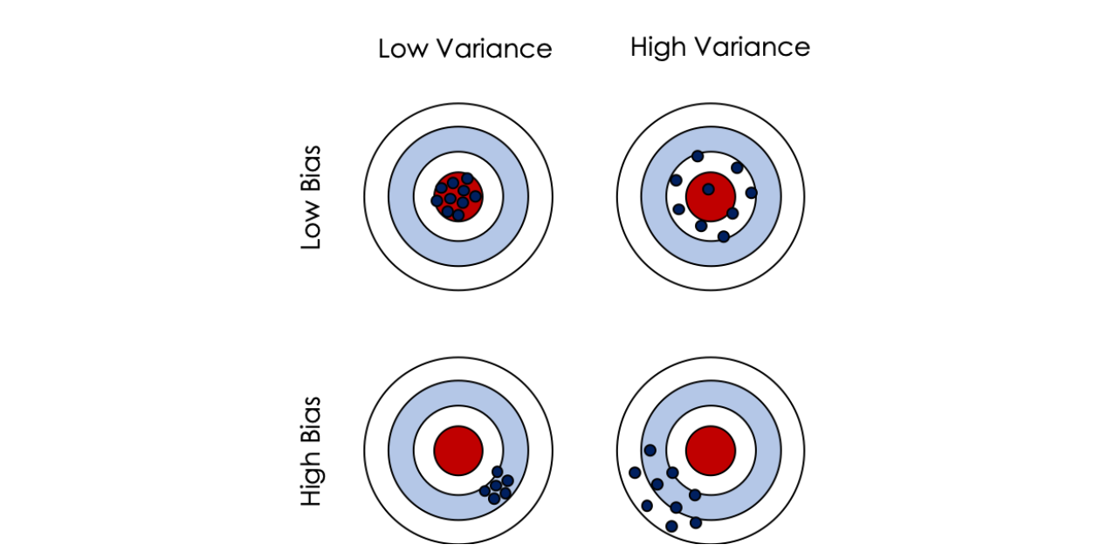

Mathematically speaking, let *f* be a true regression function: y=*f*(*x*)+*ϵ*where: *ϵ~N(0,σ²)*  
We fit a hypothesis *h*(*x*)=*Wx*+*b* with MSE and consider x_0​ be a new data point, *y_*0​=*f*(*x_*0​)+*ϵ:* the expected error can be defined by:

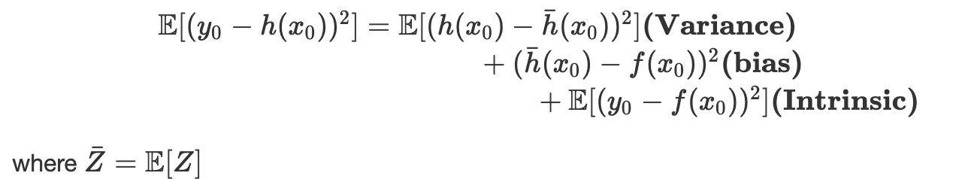

A trade-off must be found between variance and bias to find the optimum complexity of the model either by using the *AIC* criteria or using cross-validation.  
Here is a simple schema to follow to solve bias/variance issues:

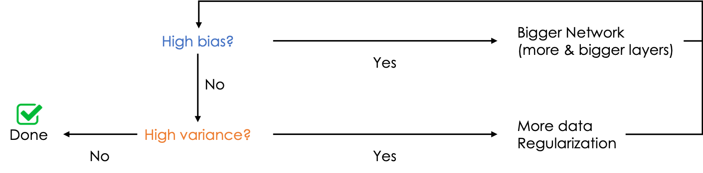

**L1 — L2 regularization**

Regularization is an optimization technique that prevents overfitting.  
It consists of adding a term in the objective function to minimize as follows:

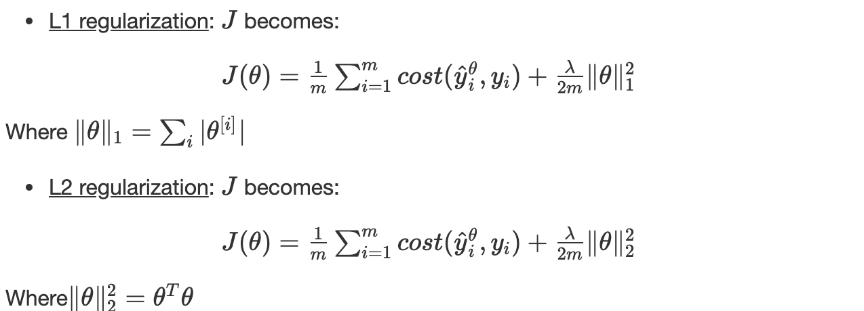

*λ* is the hyperparameter of the regularization.

**Backpropagation and regularization**  
The update of the parameters during backpropagation depends on the gradient ∇*J*, to which is added a new regularization term. In L2 regularization, it becomes as follows:





Considering *λ*>>1, minimizing the cost function leads to weak values of parameters because of the term (*λ/2m)*​∥*θ*∥ which simplifies the network and makes more consistent, hence less exposed to overfitting.

**Dropout regularization**

Roughly speaking, the main idea is to sample a uniform random variable, for each layer for each node, and have *p* chance of keeping the node and 1−*p* of removing it which diminishes the network.  
The main intuition of dropout is based on the idea that the network shouldn't rely on a specific feature but should instead spread out the weights!  
Mathematically speaking, when dropout is off and considering the *j th* node of the *i th*layer, we have the following equations:

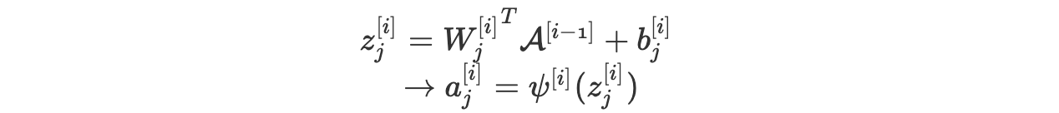

When dropout is on, the equations become as follows:

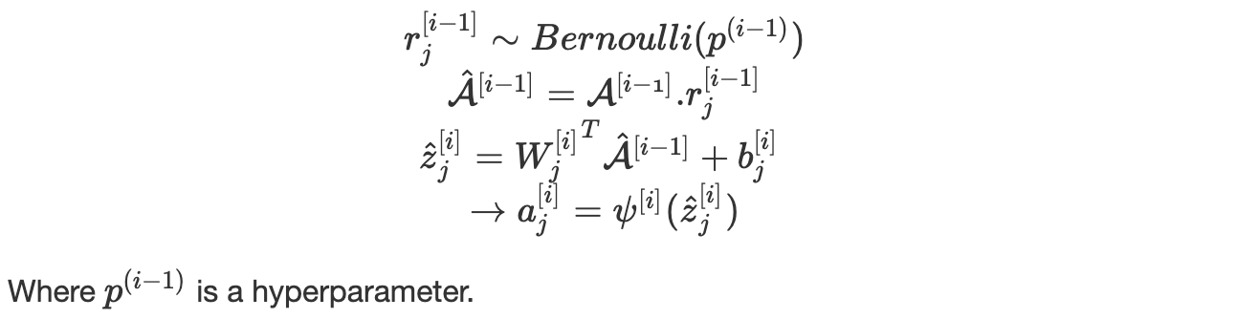

**Early stopping**

This technique is quite simple and consists of stopping the iteration around the area when *J_train*​ and *J_dev*​ start separating:

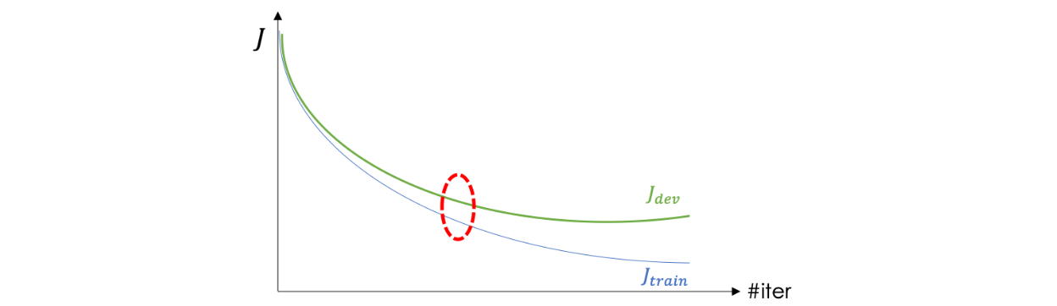

**Gradient problems**

The computation of gradients suffers from two major problems: gradient vanishing and gradient exploding.  
To illustrate both of the situations, let’s consider a neural network where all the activation functions *ψ*[*i*] are linear and:

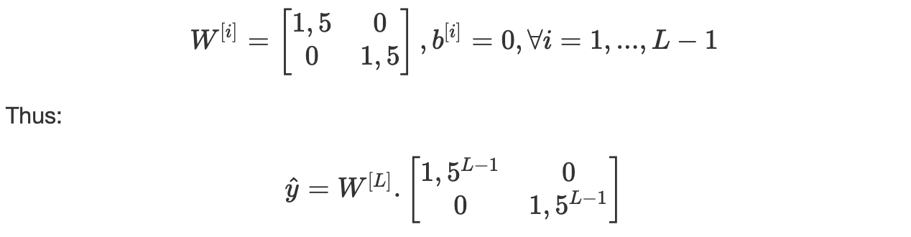

We note that 1,5^(*L*−1) will explode exponentially as a function of the depth L. If we use 0.5 instead of 1,5 then 0,5^(L-1) will vanish exponentially as well.  
The same issue occurs with gradients.

**Conclusion**

As a data scientist, it is very important to be aware of the mathematics behind neural networks. This allows better understanding and faster debugging.

**Mathematics of CNNs**

Computer vision is a subfield of deep learning which deals with images on all scales. It allows the computer to process and understand the content of a large number of pictures through an automatic process.  
The main architecture behind Computer vision is the convolutional neural network which is a derivative of feedforward neural networks. Its applications are varied such as image classification, object detection, neural style transfer, face identification.

**List of Topics Covered**

1. Filter processing  
2. Definition  
3. Foundations  
4. Training the CNN  
5. Common architectures

**1- Filter processing**

The first processing of images was based on filters that allowed, for instance, to get the edges of an object in an image using the combination of vertical-edge and horizontal-edge filters.  
Mathematically speaking, the vertical edge filter, VEF, if defined as follows:

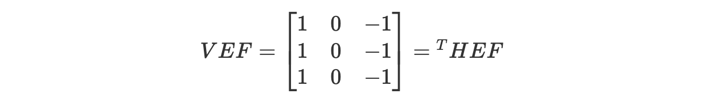

Where HEF stands for the horizontal edge filter.

For the sake of simplicity, we consider grayscale 6x6 image A, a 2D matrix where the value of each element represents the amount of light in the corresponding pixel.  
In order to extract the vertical edges from this image, we carry out a **convolutional product (⋆)** which is basically **the sum of the elementwise product in each block**:

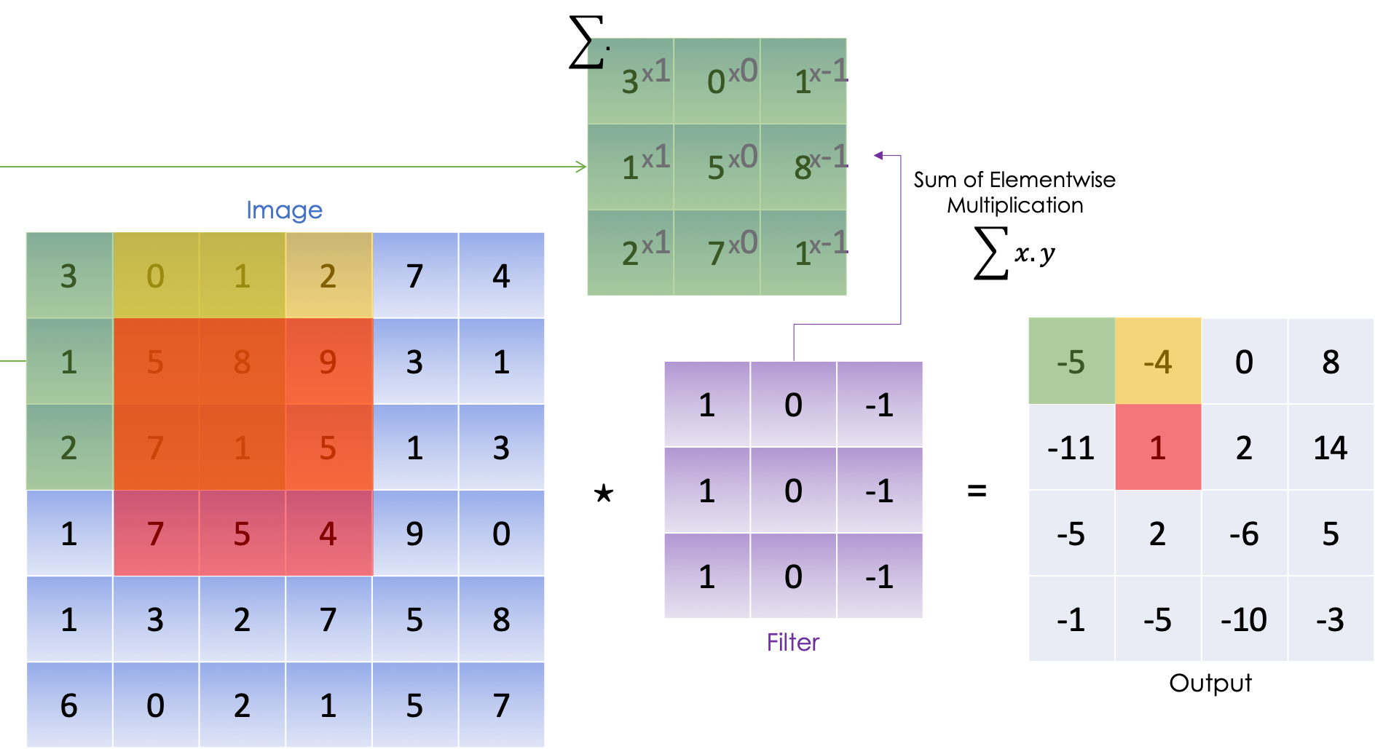

We carry out the elementwise multiplication on the first 3x3 block of the image then we consider the following block on the right and do the same thing until we have covered all the potential blocks.

We can sum up the following process in:

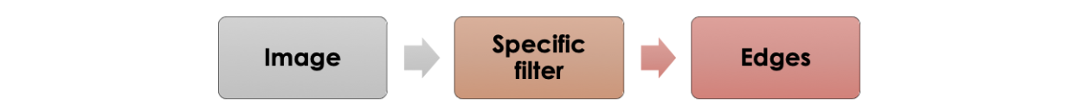

Given this example, we can think of using the same process for any objective where the filter is learned by neural network as follows:

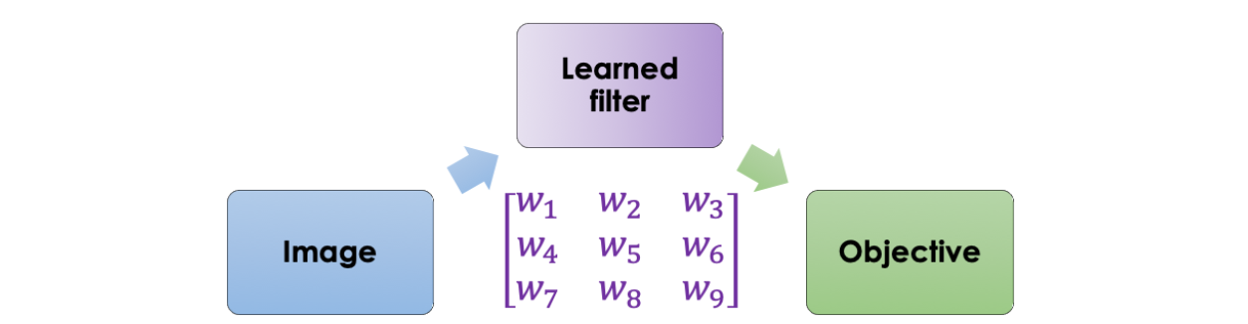

The main intuition is to create a neural network that takes the image as an input and outputs a defined target. The parameters are learned using backpropagation.

**2- Definition**

A convolutional neural network is a series of convolutional and pooling layers which allow extracting the main features from the images responding the best to the final objective.

In the following section, we will detail each brick along with its mathematical equations.

**Convolution product**

Before we explicitly define the convolution product, we will first start by defining some basic operations such as the padding and the stride.

**Padding**

As we have seen in the convolutional product using the vertical-edge filter, the pixels on the corner of the image (2D matrix) are less used than the pixels in the middle of the picture which means that the information from the edges is thrown away.  
To solve this problem, we often add padding around the image in order to take the pixels on the edges into account. In convention, we pad with zeros and denote with p the padding parameter which represents the number of elements added on each of the four sides of the image.  
The following picture illustrates the padding of a grayscale image (2D matrix) where p=1:

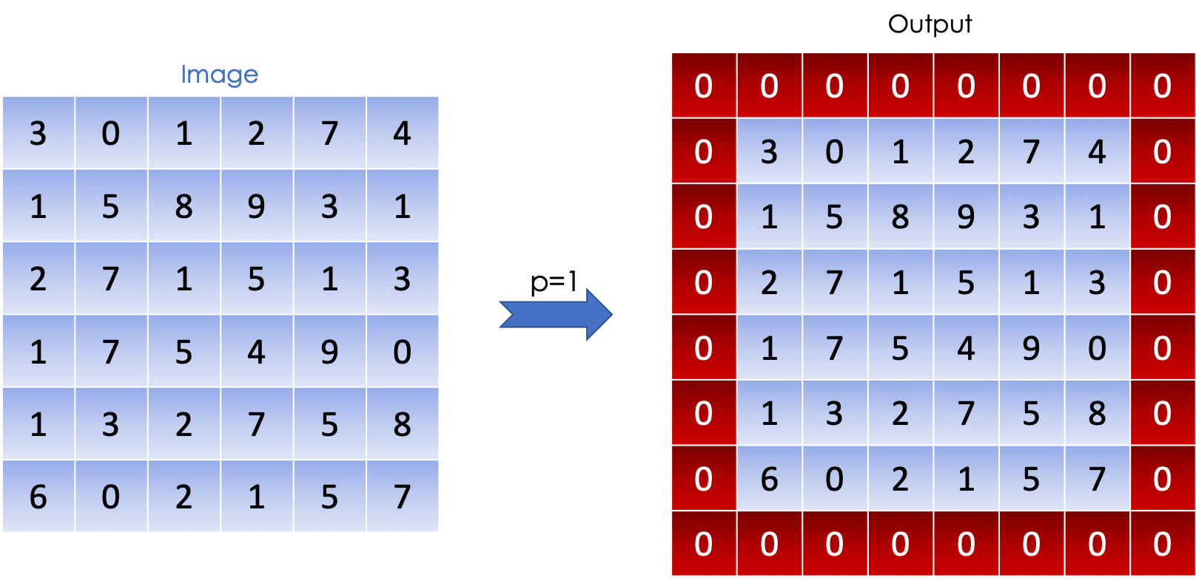

**Stride**

The stride is the step taken in the convolutional product. A large stride allows to shrink the size of the output and vice-versa. We denote s the stride parameter.  
The following image illustrates a convolutional product (sum of element-wise element per block) with s=1:

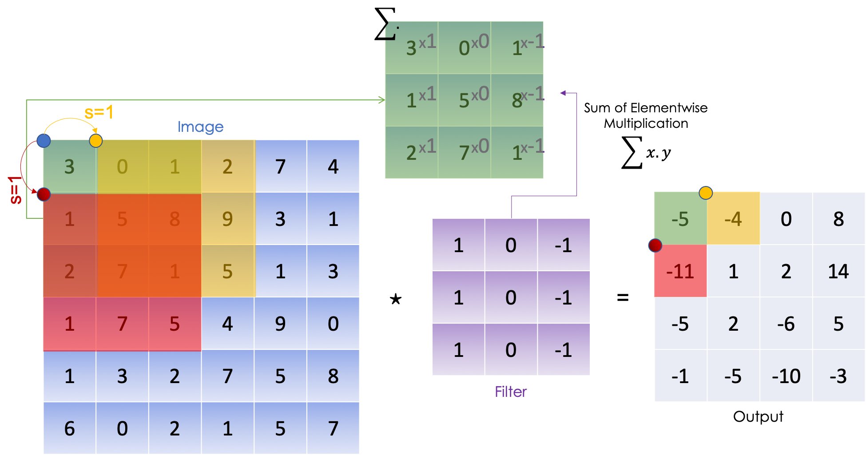

**Convolution**

Once we have defined the stride and the padding we can define the convolution product between a tensor and a filter.  
After previously defining the convolution product on a 2D matrix which is the sum of the element-wise product, we can now formally define the convolution product on a volume.  
An image, in general, can be mathematically represented as a tensor with the following dimensions:

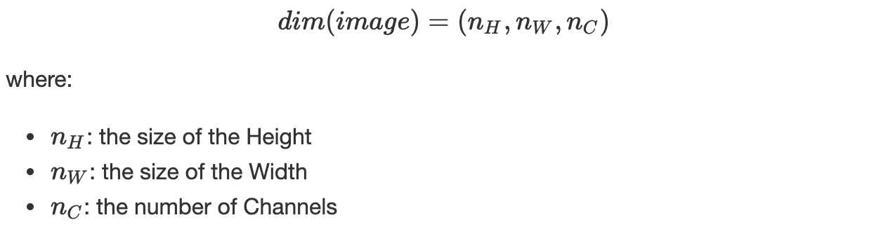

In the case of an RGB image, for instance, n_C=3, we have, Red, Green and Blue. In convention, we consider the filter *K* to be squared and to have an odd dimension denoted *f,*which allows each pixel to be centered in the filter and thus consider all the elements around it.  
When operating the convolutional product, the filter/kernel *K* must have the same number of channels as the image, this way we apply a different filter to each channel. Thus the dimension of the filter is as follows:



The convolutional product between the image and the filter is a 2D matrix where each element is the **sum of the elementwise multiplication** of the cube (filter) and the sub cube of the given image as illustrated below:

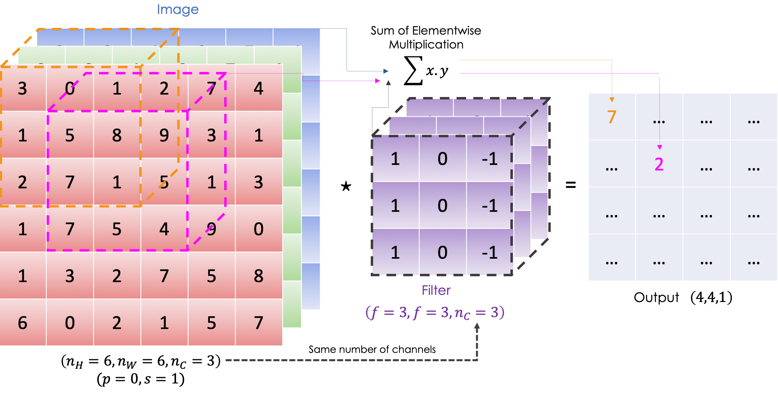

Mathematically speaking, for a given image and filter we have:



Keeping the same notations as before, we have:

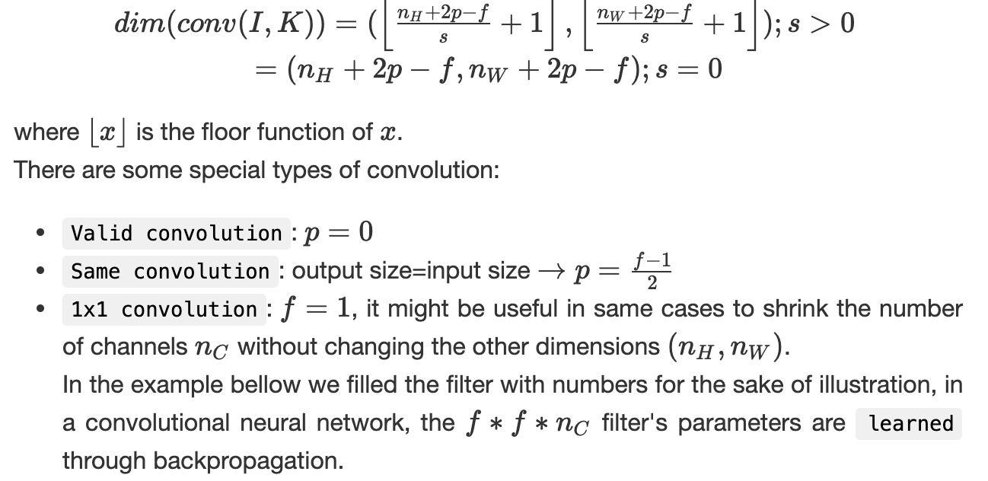

**Pooling**

It is the step of downsampling the image’s features through summing up the information. The operation is carried out through each channel and thus it only affects the dimensions (n_H, n_W)and keeps n_C intact.  
Given an image, we slide a filter, with no parameters to learn, following a certain stride, and we apply a function on the selected elements. We have:

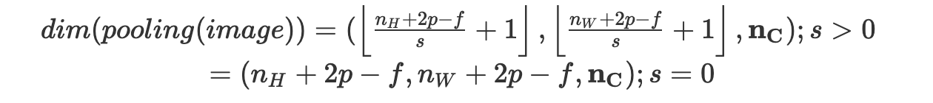

In convention, we consider a squared filter with size *f* and we usually set *f*=2 and consider *s*=2.

We often apply:

* Average pooling: we average on the elements present on the filter
* Max pooling: given all the elements in the filter, we return the maximum

Bellow, an illustration of an average pooling:

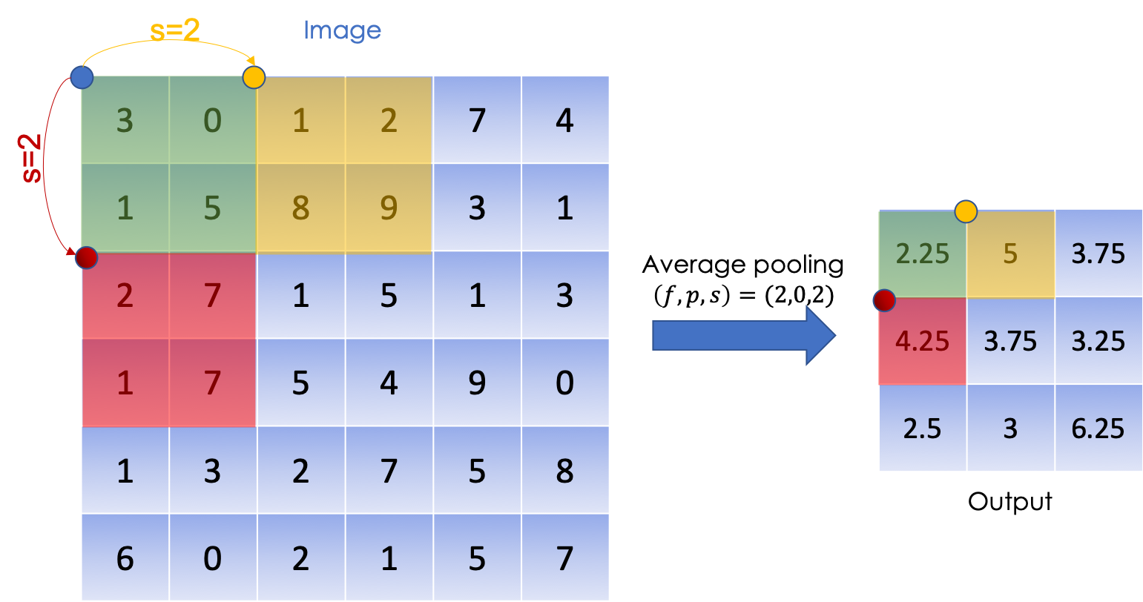

**3- Foundations**

In this section, we will combine all the operations defined above to construct a convolutional neural network, layer per layer.

**One layer of a CNN**

Each layer of the convolutional neural network can either be:

* Convolutional layer -CONV- followed with an activation function
* Pooling layer -POOL- as detailed above
* Fully connected layer -FC- a layer which is basically similar to one from a feedforward neural network,

You can have more details on the activations functions and the fully connected layer in the previous section

**• Convolutional layer**

As we have seen before, at the convolutional layer, we apply convolutional product**s**, using many filters this time, on the input followed by an activation function ψ.

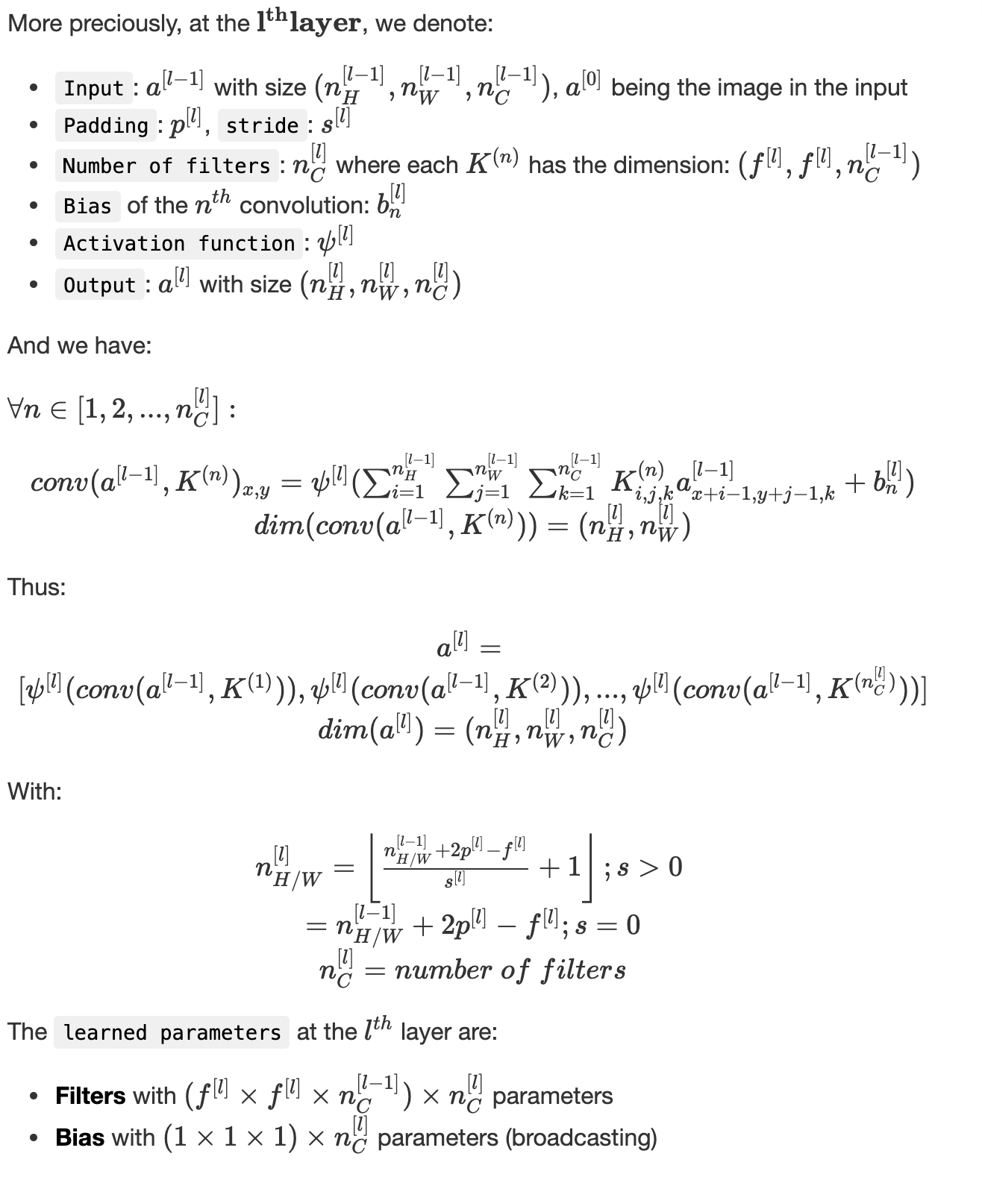

We can sum up the convolutional layer in the following graph:

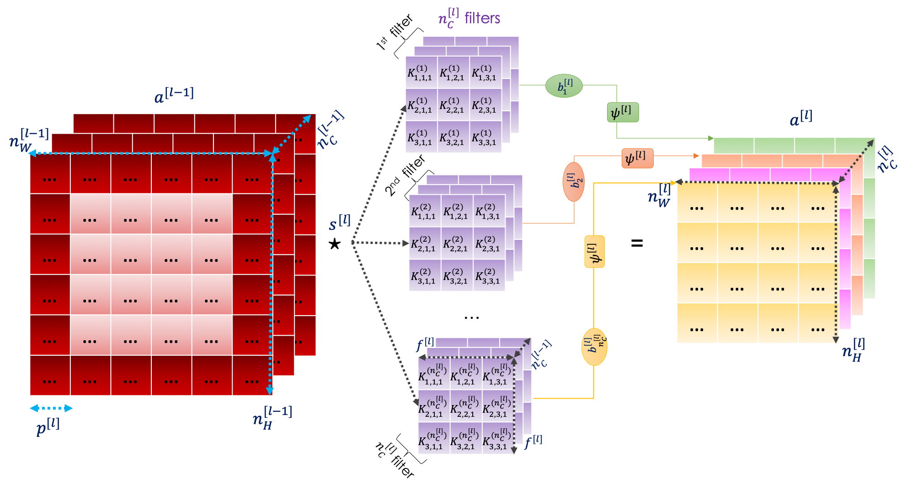

**• Pooling layer**

As mentioned before, the pooling layer aims at downsampling the features of the input without impacting the number of the channels.  
We consider the following notation:

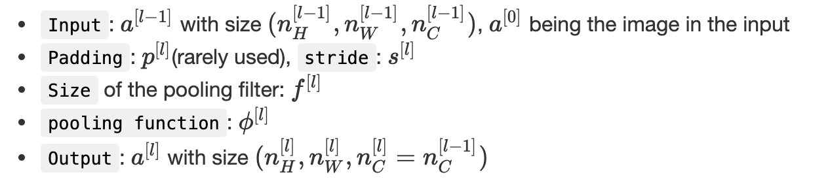

We can assert that:

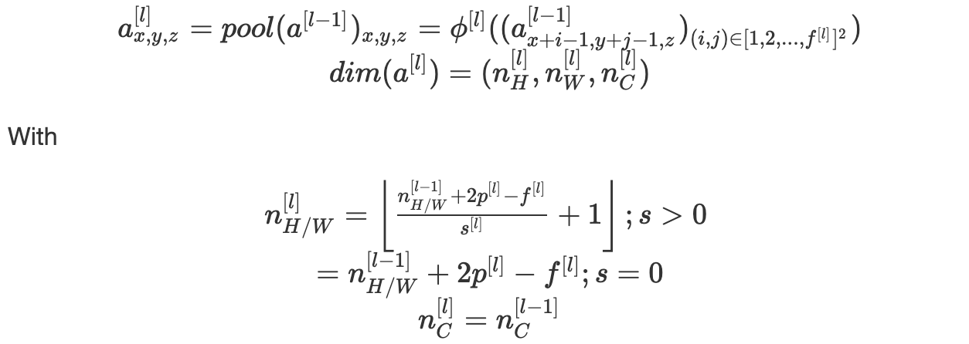

The pooling layer has no parameters to learn.

We sum up the previous operations in the following illustration:

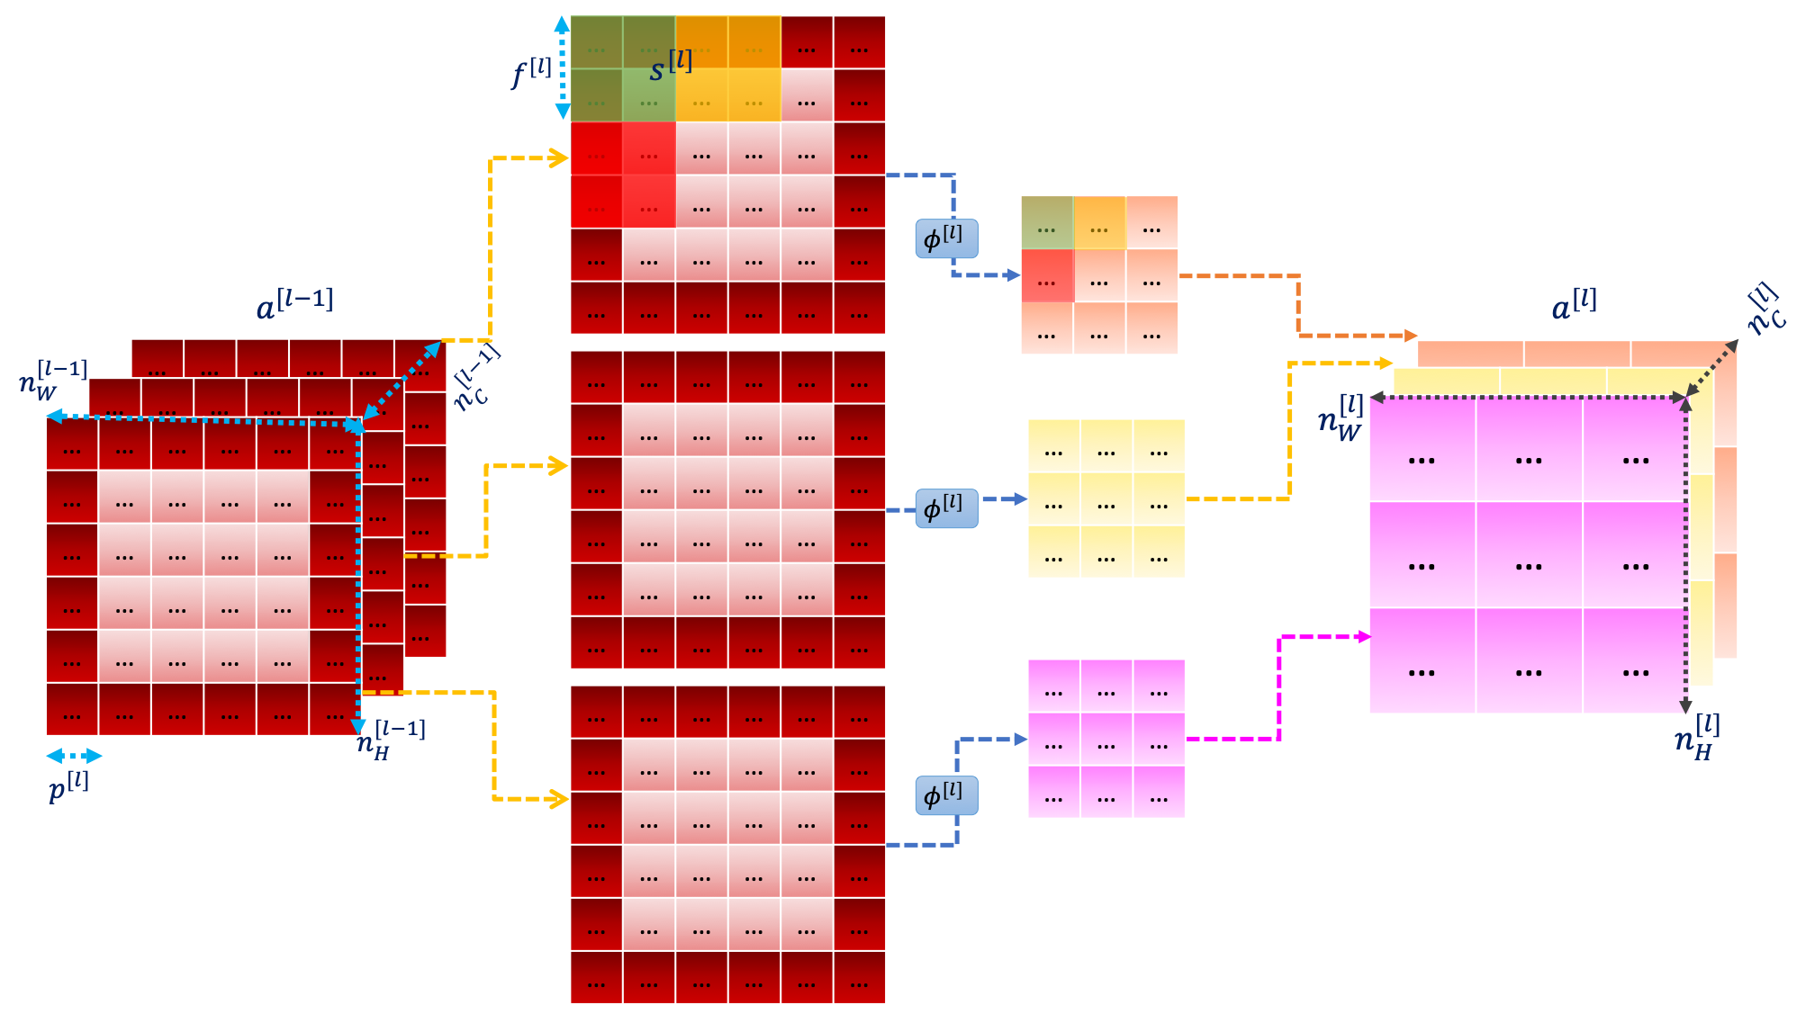

**• Fully connected layer**

A fully connected layer is a finite number of neurons which takes in input a vector and returns another one.

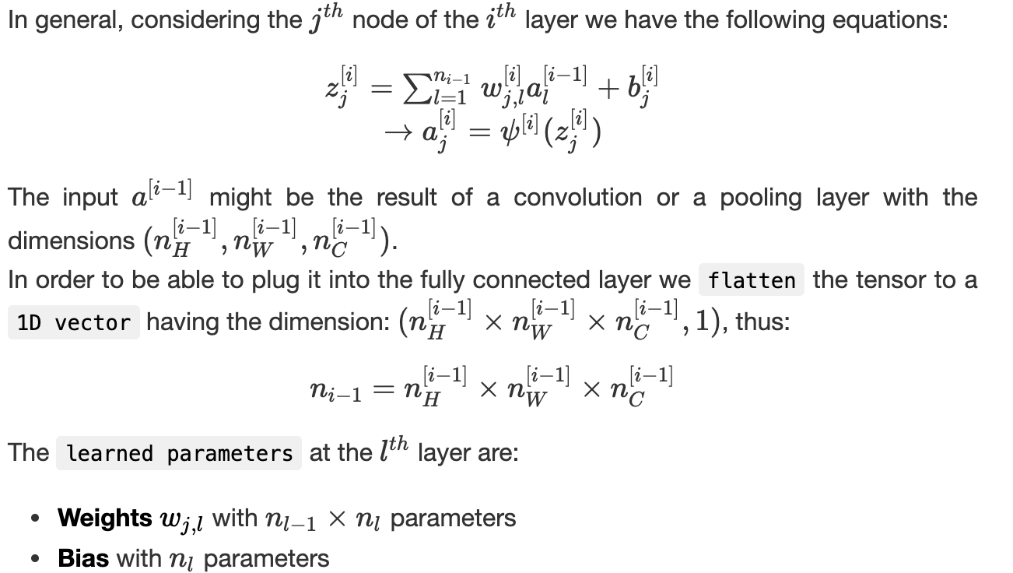

We sum up the fully connected layer in the following illustration:

For more details, you can refer to the previous section on feedforward neural networks.

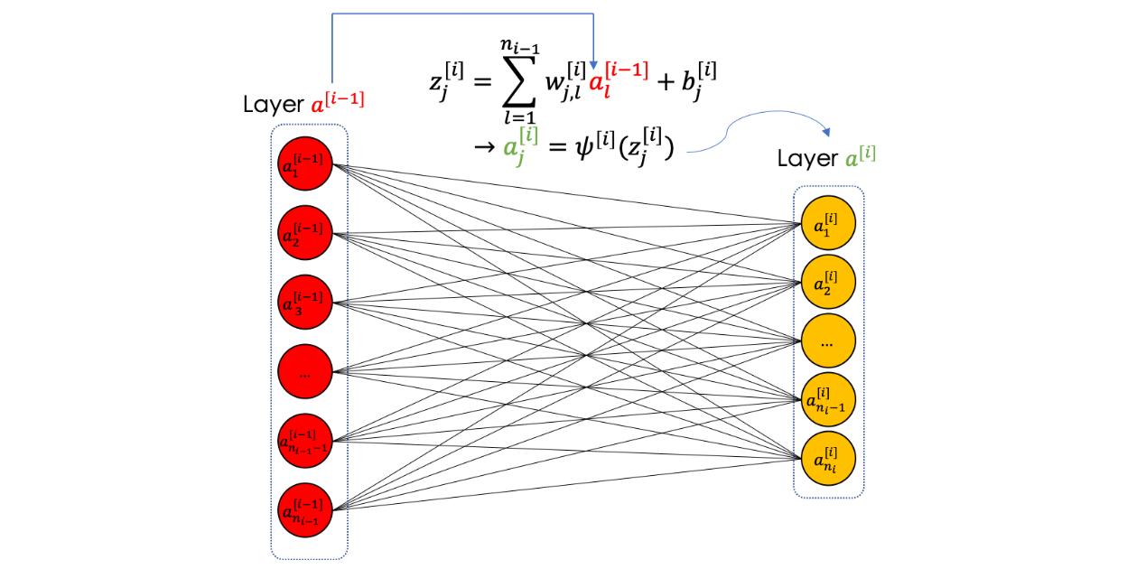

**CNN in Overall**

In general, a convolutional neural network is a series of all the operations described above as follows:

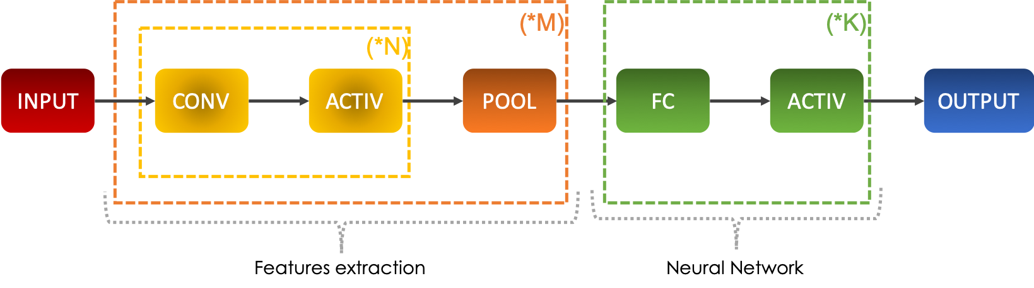

After repeating a series of convolutions followed by activation functions, we apply a pooling and repeat this process a certain number of time. These operations allow to extract features from the image that will be fed to a neural network described by the fully connected layers which are regularly followed by activation functions as well.  
The main idea is to decrease n_H & n_W and increase n_C when going deeper through the network.  
In 3D, a convolutional neural network has the following shape:

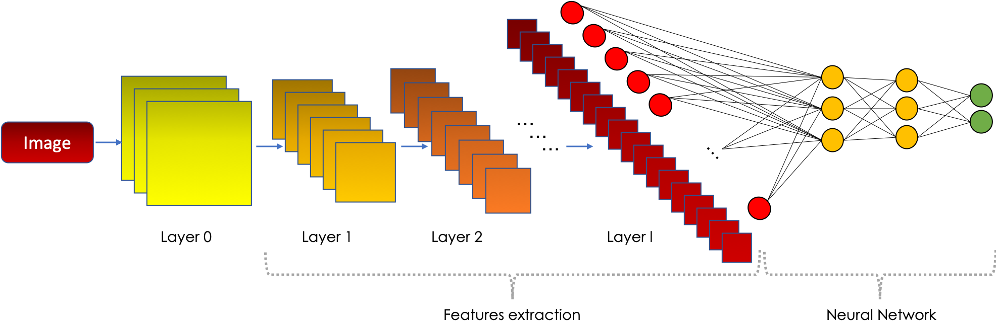

**Why do CNN work efficiently?**

Convolutional neural networks enable the state of the art results in image processing for two main reasons:

* **Parameter sharing**: a feature detector in the convolutional layer which is useful in one part of the image, might be useful in other ones
* **Sparsity of connections**: in each layer, each output value depends only on a small number of inputs

**4- Training the CNN**

Convolutional neural networks are trained on a set of labeled images. Starting from a given image, we propagate it through the different layers of the CNN and return the sought output.  
In this chapter, we will go through the learning algorithm along with the different techniques used in the data augmentation.

**Data preprocessing**

**Data augmentation** is the step of increasing the number of images in a given dataset. There are many techniques used in data augmentation such as:

* Cropping
* Rotation
* Flipping
* Noise injection
* Color space transformation

It enables better learning due to the bigger size of the training set and allows the algorithm to learn from different conditions of the object in question.  
Once the dataset is ready, we **split** it into three parts like any machine learning project:

* **Train set**: used to train the algorithm and construct batches
* **Dev set**: used to finetune the algorithm and evaluate bias and variance
* **Test set**: used to generalize the error/precision of the final algorithm

**Learning algorithm**

Convolutional neural networks are a special kind of neural networks specialized in images. Learning in neural networks, in general, is the step of calculating the weights of the parameters defined above in several layers.  
In other words, we aim to find the best parameters that give the best prediction/approximation, starting from the input image, of the real value.  
For this, we define an objective function called the loss function and denoted J which quantifies the distance between the real and the predicted values on the overall training set.  
We minimize J following two major steps:

* **Forward Propagation**: we propagate the data through the network either in entirely or in batches, and we calculate the loss function on this batch which is nothing but the sum of the errors committed at the predicted output for the different rows.
* **Backpropagation**: consists of calculating the gradients of the cost function with respect to the different parameters, then apply a descent algorithm to update them.

We iterate using the same process a number of times called epoch number. After defining the architecture, the learning algorithm is written as follows:

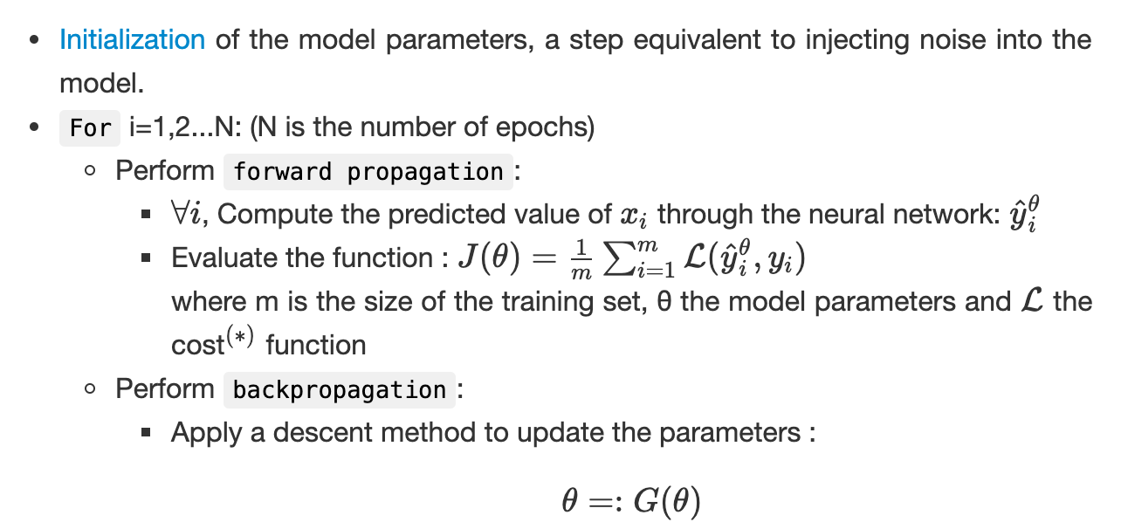

(*) The cost function evaluates the distances between the real and predicted value on a single point.

For more details, you can visit the previous section on feedforward neural networks.

**5- Common architectures**

**Resnet**

A Resnet, short cut or a skip connection is a convolutional layer which takes into account the layer *n-2* at the layer *n* . The intuition comes from the fact that when neural networks get very deep, the accuracy at the output becomes very stable and does not increase. Injecting residuals from the previous layer help solve this problem.  
Let’s consider a residual block, when the skip connection is off, we have the following equations:

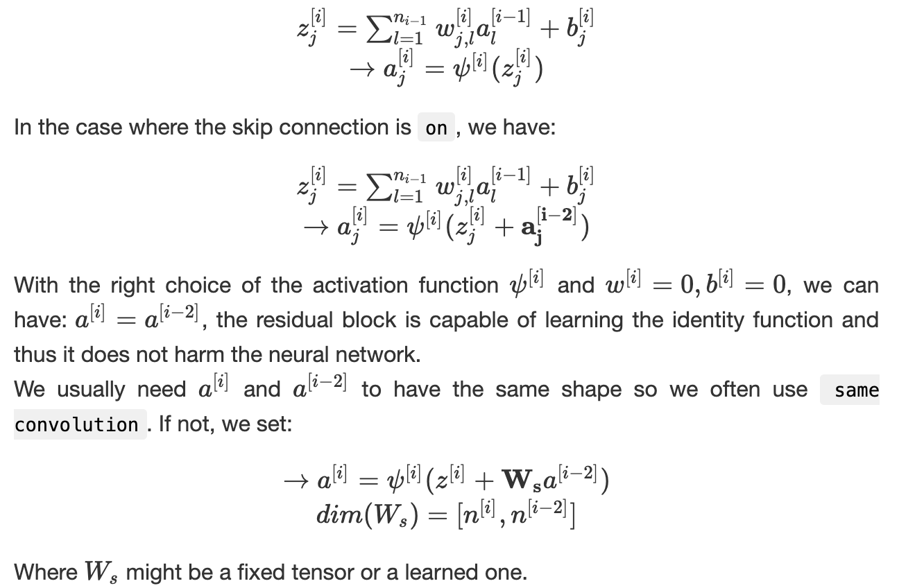

We can sum up the residual block in the following illustration:

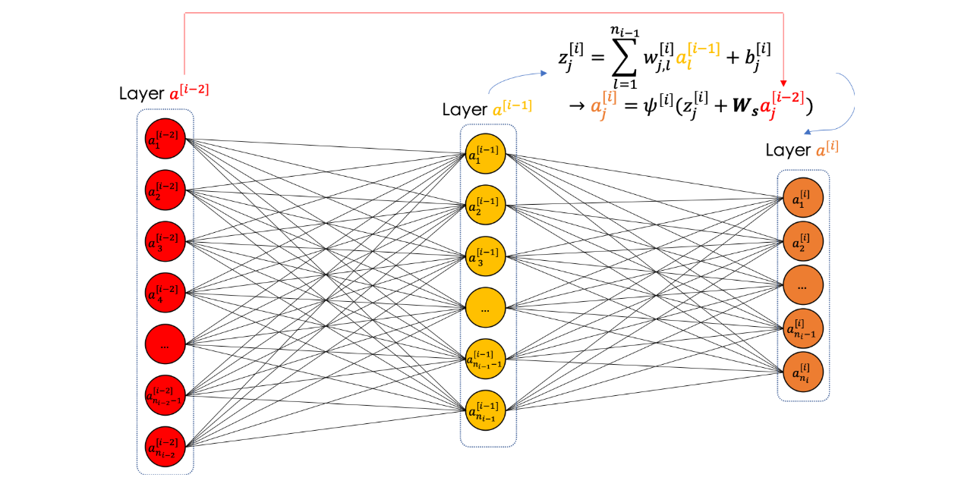

**Inception Networks**

When designing a convolutional neural network, we often have to choose the type of the layer: CONV, POOL or FC. The inception layer does them all. The result of all the operations is then concatenated in a single block which will be the input of the next layer as follows:

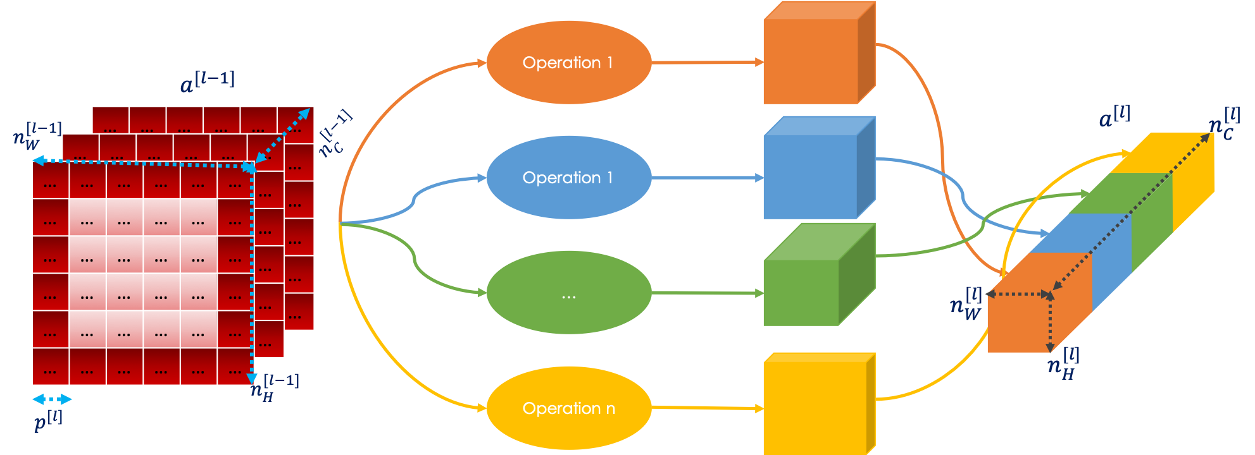

It is important to note that the inception layer raises the problem of computational cost. For information, the name inception comes from the movie!

**Conclusion**

In this section, we have seen the fundamentals of CNN from convolutional products, pooling/fully connected layers to the training algorithm.

**The Mathematics of Object Detection and Face Recognition using CNNs**

Convolutional neural networks are widely used in addressing image-based problems, such as object/character detection and face recognition. In this article, we will focus on the most famous architectures from LeNet to Siamese networks, having for most of them the following architecture:



# List of Topics covered

1. Cross-Entropy  
2. Image classification  
3. Object detection — YOLOv3  
4. Face Recognition — Siamese Networks

# 1- Cross-Entropy

When classifying an image, we often use a softmax function at the last layer having the size (C,1) where C is the number of classes in question.  
The i th line of the vector is the probability that the input image belongs to the class i. The predicted class is set to be the one corresponding to the highest probability.

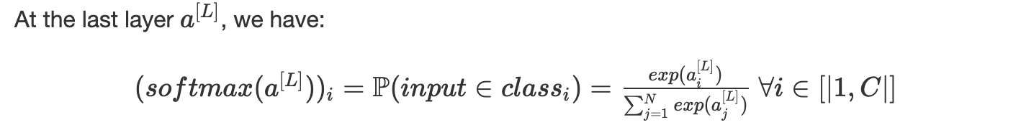

The network learns by using [backpropagation](https://towardsdatascience.com/deep-learnings-mathematics-f52b3c4d2576) and optimizes the cross entropy defined as follows:



Where

* p(x,class) is the reference probability and equals 1 if the object really belongs to the class filled out and 0 otherwise
* q(x,class) is the probability, learned by the network through the softmax, that the object x belongs to that class

For an input x∈class_j​:



Thus, we set the loss function as:



We average the loss, where m is the size of the training set.

# 2- Image classification

## LeNet — Digits Recognition

LeNet is an architecture developed by [Yann Lecun](https://www.linkedin.com/in/yann-lecun-0b999/) in and it aims at detecting the digit present in the input.  
Given gray-scale images of hand-written digits from 0 to 9, the convolutional neural network predicts the digit of the image.  
The trainset is called MNIST, which is a dataset containing more than 70k images having 28x28x1 pixels. The neural network has the following architecture counting more than 60k parameters:

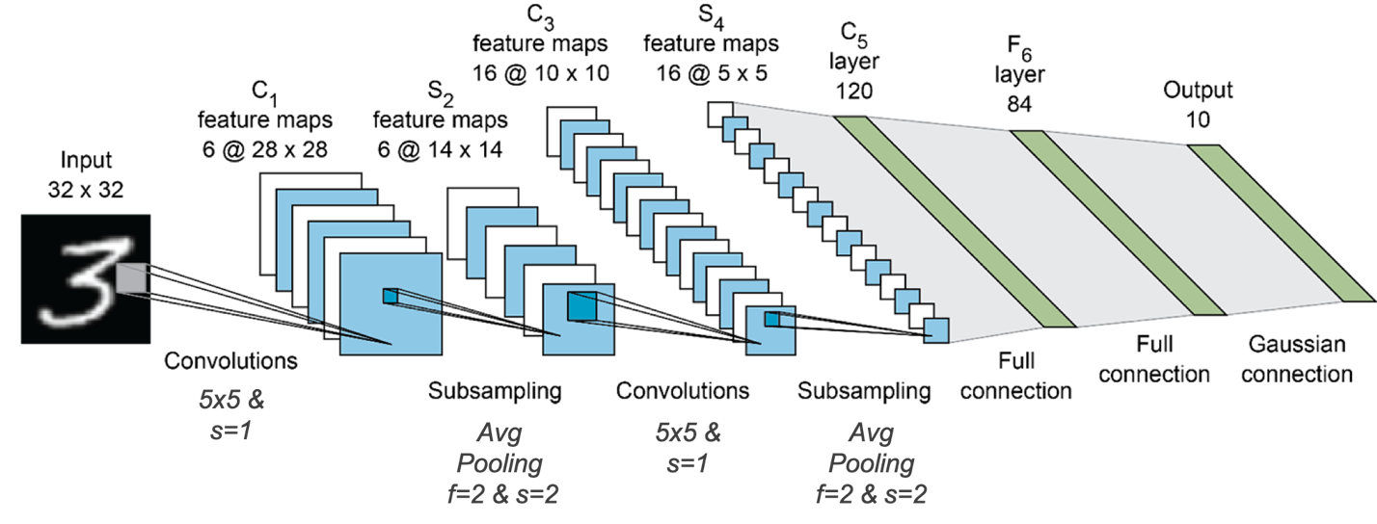

shorturl.at/iEJP5

For more details, I advise you to read the official [paper](http://yann.lecun.com/exdb/publis/pdf/lecun-01a.pdf).

## AlexNet

AlexNet is a famous architecture which won the ImageNet competition in 2012. It is similar to LeNet but has more layers, dropouts and ReLU activation function most of time.

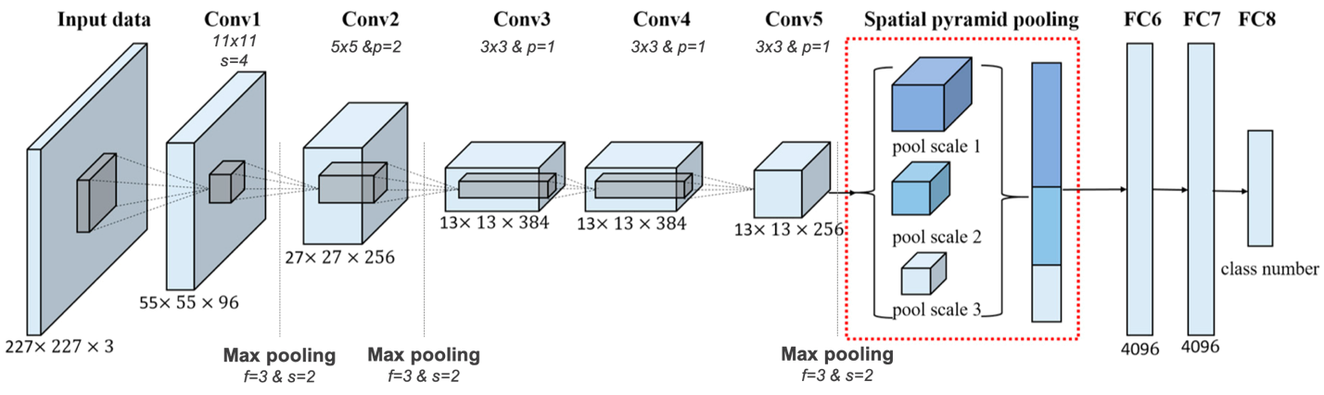

shorturl.at/cdguA

The training set is a subset of the ImageNet database, a 15 million [labeled images](http://www.image-net.org/) having a high resolution and representing more than 22k categories.  
AlexNet used more than 1.2 million images in the training set, 50k in the validation set and 150k in the test set, which were all resized to 227x227x3. The architecture has more than 60 million parameters and thus was trained on 2 GPUs, it outputs a softmax vector with size (1000,1) .

For more information, I advise you to read the official [paper](https://papers.nips.cc/paper/4824-imagenet-classification-with-deep-convolutional-neural-networks.pdf).

## VGG-16

VGG-16 in a convolutional neural network for image classification, trained on the same dataset ImageNetand has more than 138 million parameters trained on GPUs.  
The architecture is the following:

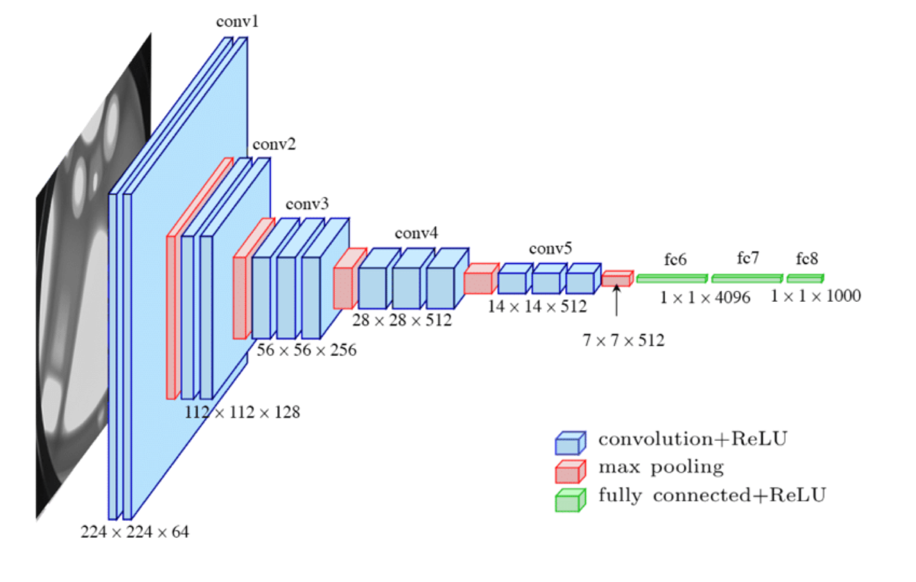

shorturl.at/mqDZ6

It is more accurate and deeper than AlexNet since it replaced the large kernels 11x11x5 and 5x5 by successive 3x3 kernels.  
For more details, check the official [paper](https://arxiv.org/pdf/1409.1556.pdf) of the VGG project.

# 3- Object detection — YOLO

Object detection is the task of detecting multiple objects in an image that requires both object localization and object classification. A first rough approach would be sliding a window with customizable dimensions and predict each time the class of the content using a network trained on cropped images. This process has a high computational cost and can luckily be automized using convolutions.  
YOLO stands for **Y**ou **O**nly **L**ook **O**nce and the basic idea consists of placing a grid on the image (usually 19x19) where:

*Only one cell, the one containing the center/midpoint of an object is responsible for detecting this object*

Each cell of the grid (i,j) is labeled as follows:

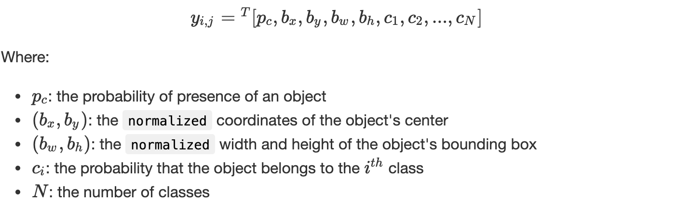

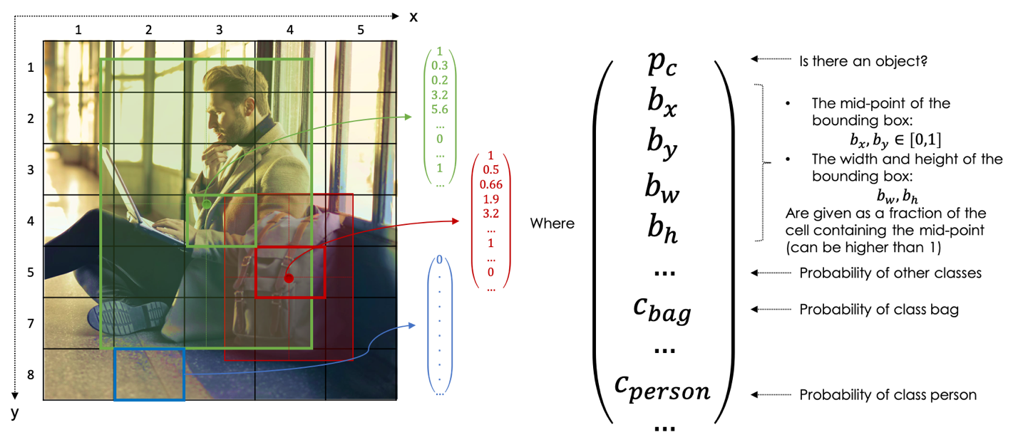

Hence, for each image the target output is of size:

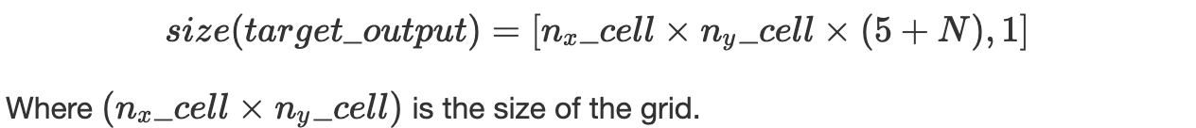

## IOU & NMS

In order to evaluate the object localization, we use the **I**ntersection **O**ver **U**nion which measures the overlap between two bounding boxes:

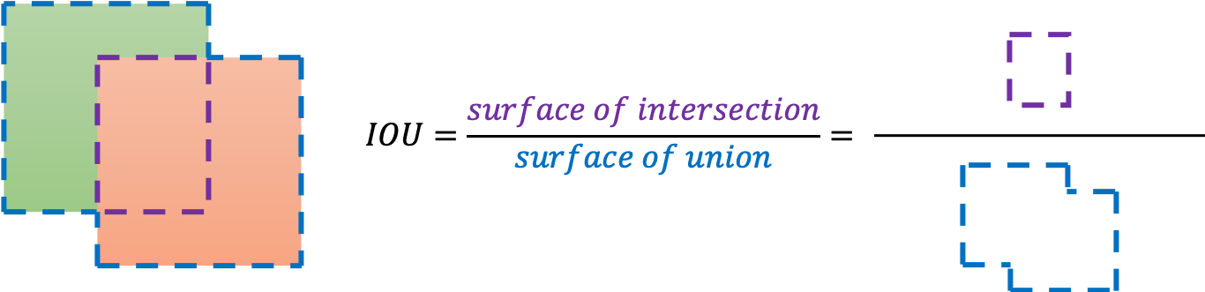

When predicting the bounding box of a given object in a given cell of the grid, many outputs might be given, Non-Max Suppression helps you detect the object only once. It takes the highest probability and suppresses the other boxes having a high overlap (IOU).  
For each cell of the grid, the algorithm is the following:

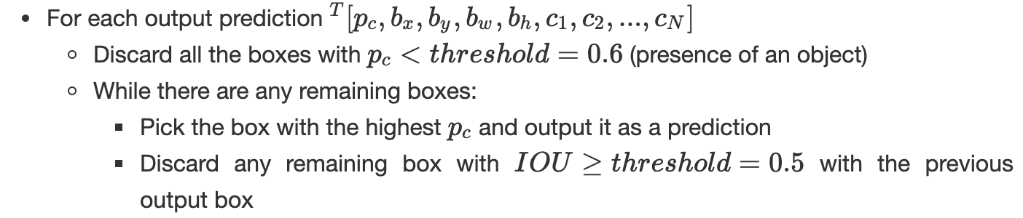

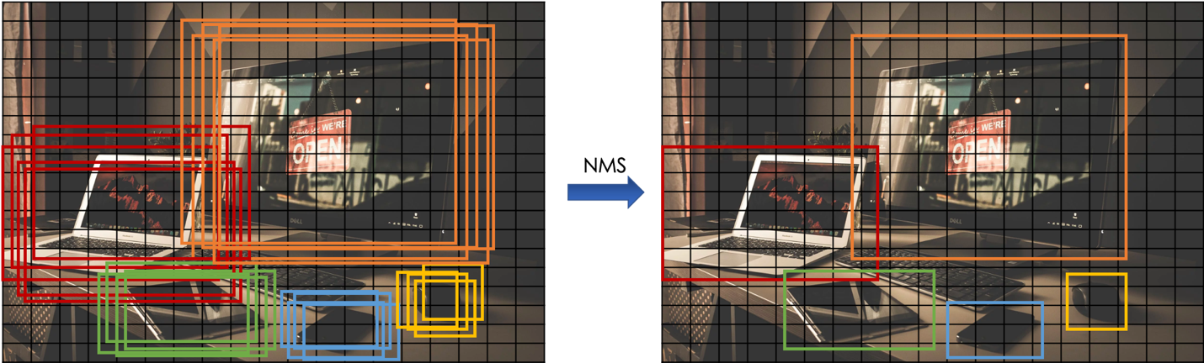

## Anchor Boxes

In most cases, a grid cell might contain multiple objects, anchor boxes allow the detection of all of them. In case of 2 anchor boxes, each cell of the grid is labeled as follows:



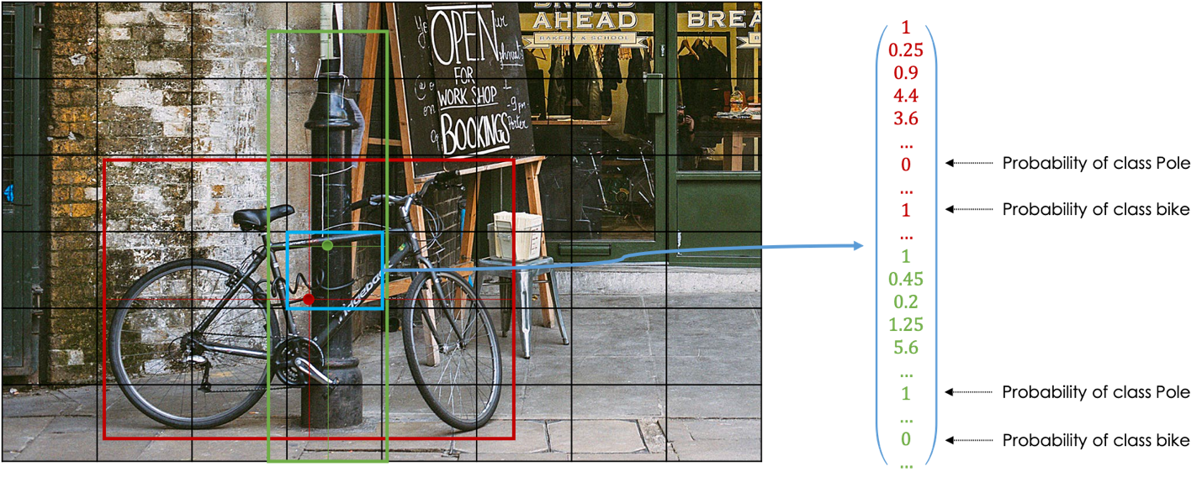

More general, the output target is of size:



Where is N the number of classes and M the number of anchor boxes.

## YOLOv3 Algorithm

YOLO was trained on [coco](http://cocodataset.org/#home) dataset, a large-scale object detection, segmentation and captioning database with 80 object categories. YOLOv3 has a Darknet-53 architecture as feature extractor also called a backbone.

The training is carried out by minimizing a loss function using gradient methods as well.  
It is combined of:

* Logistic regression loss on p_c​
* Squared error loss for b_i​
* Softmax loss(cross-entropy) for the probabilities c_i​

At each epoch, in each cell, we generate the output y_(i,j) and evaluate the loss function.  
When making predictions, we check that p_c is high enough and for each grid-cell, we get rid of low probability prediction and use non-max suppression for each class to generate the final output.  
For more information, I advise you to read the official [paper](https://arxiv.org/pdf/1804.02767.pdf).

# 4- Face Recognition — Siamese Networks

Siamese networks are neural networks, often convolutional, which allow to calculate the degree of similarity between two inputs, images in our case, as follows:

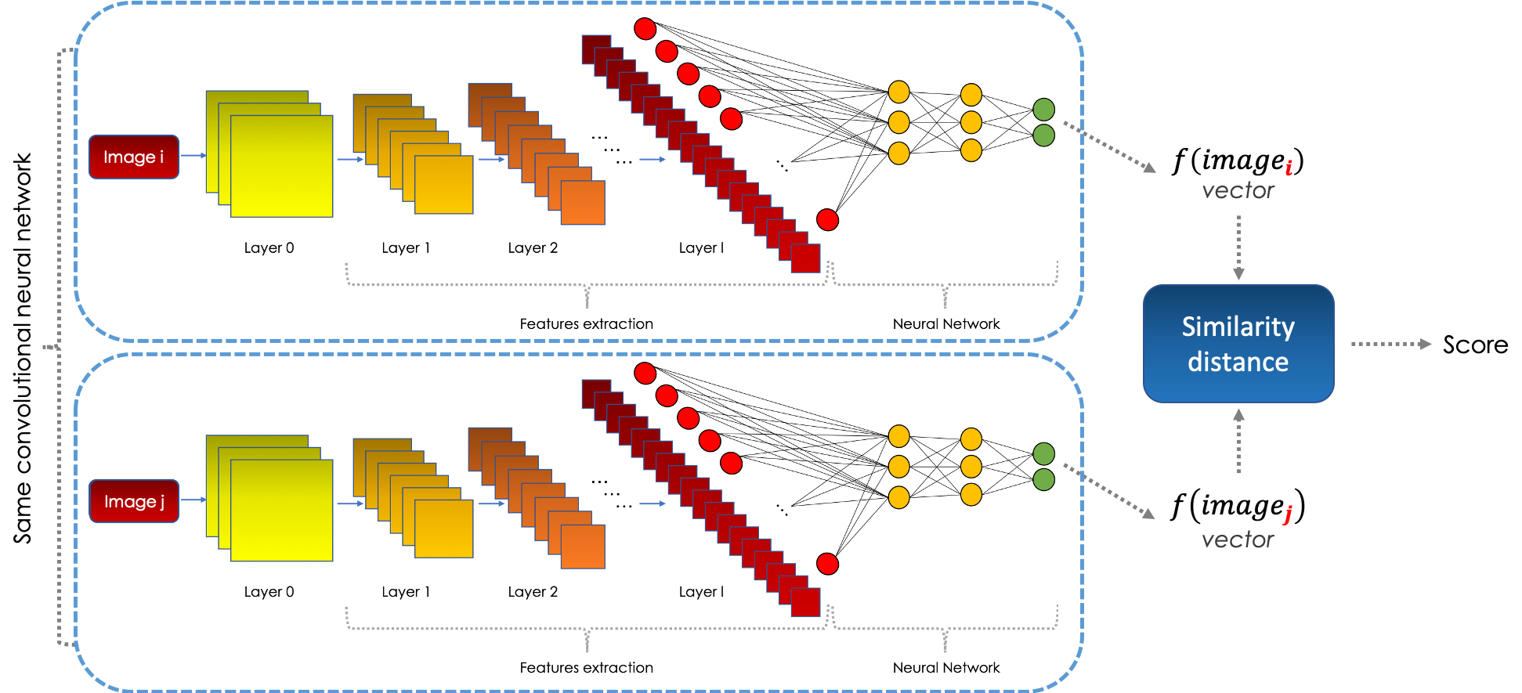

The purpose of the CNN module is to represent the information on the image in another space, called embedding space thanks to a function. We then, compare the two embeddings using a certain distance. Learning in Siamese networks is done by minimizing an objective function composed of a loss function called triplet.

The triplet function takes 3 vector variables as an input: an Anchor **A**, a positive **P**(similar to **A**) and a last negative **N**(different from **A**). Thus, we are looking to have:



Where ∥x∥²=<x,x> for a given scalar product.

To prevent the learned function f from being null, we define the margin 0<α≤1 so that:



Thus, we define the loss function as follows:



Starting from a learning database of size n, the objective function to be minimized is:



When training the architecture and for each epoch, we fixe the number of triplets and for each one:

* We randomly choose two images of the same class (Anchor & Positive)
* We randomly pick an image from another class (Negative)

A triplet (**A**, **N**, **P**) can be:

* **Easy negative**, when ∥f(A)−f(P)∥²+α−∥f(A)−f(N)∥²≤0
* **Semi-hard negative**, when ∥f(A)−f(P)∥²+α>∥f(A)−f(N)∥²>∥f(A)−f(P)∥²
* **Hard negative**, when ∥f(A)−f(N)∥²<∥f(A)−f(P)∥²

We usually choose to focus on the semi-hard negatives to train the neural network.

## Application: Face Recognition

Siamese networks can be used to develop a system capable of identifying faces. Given an image taken by camera, the architecture compares it to all the images in the database.  
Since we can not have multiple images of the same person in our database, we usually train the siamese network on an open-source imageset rich enough to create the triplets.

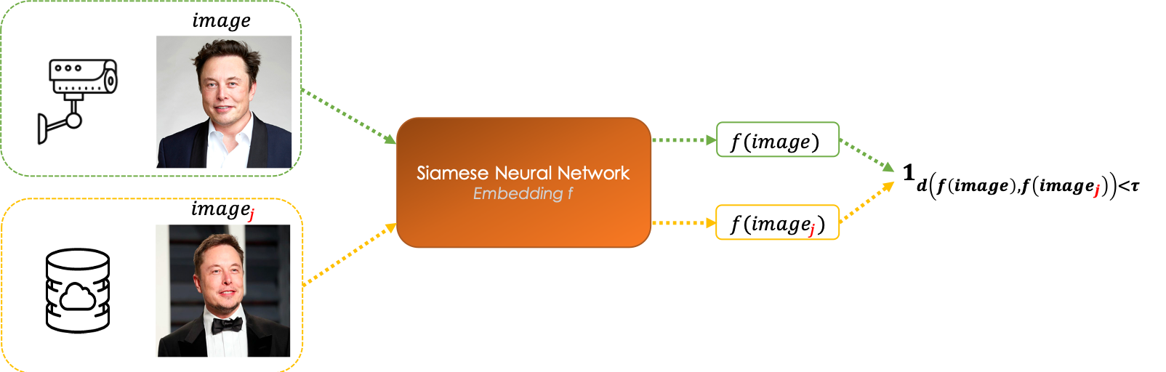

The convolutional neural network learns a similarity function f which is the embedding of the image.  
Given a camera-picture, we compare it to each image_j​ fo the database such that:

* If d(f(image, image_j​))≤τ, both of the image represent the same person
* If d(f(image, image_j​))>τ, the images are of two different persons

We choose the face image_j​ which is the closest to the image in terms of the distance d. The threshold τ is chosen in such a way that the F1​-score is the highest for example.

# Conclusion

CNNs are widely used architectures in image processing, they enable better and faster results. Recently they have been also used in text processing where the input of the network is the embedding of the tokens instead of the pixels of the images.

# The Mathematics of RNNs

Recurrent neural networks are very famous deep learning networks which are applied to sequence data: time series forecasting, speech recognition, sentiment classification, machine translation, Named Entity Recognition, etc..  
The use of feedforward neural networks on sequence data raises two major problems:

* Input & outputs can have different lengths in different examples
* MLPs do not share features learned across different positions of the data sample

In this article, we will discover the mathematics behind the success of RNNs as well as some special types of cells such as LSTMs and GRUs. We will finally dig into the encoder-decoder architectures combined with attention mechanisms.

NB: Since Medium does not support LaTeX, the mathematical expressions are inserted as images. Hence, I advise you to turn the dark mode off for a better reading experience.

# List of Topics Covered

1. **Notation**
2. **RNN model**
3. **Different types of RNNs**
4. **Advanced types of cells**
5. **Encoder & Decoder architecture**
6. **Attention mechanisms**

# 1. Notation

As an illustration, we will consider the task of Named Entity Recognition which consists of locating and identifying the named entity such as proper names:

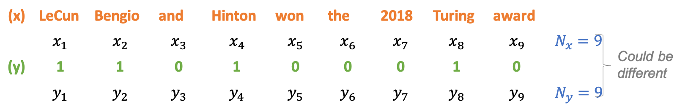

We denote:

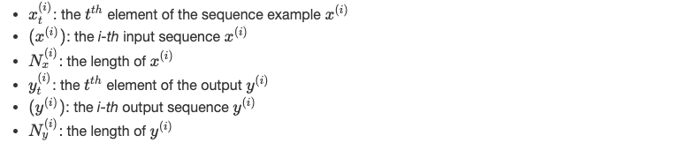

When dealing with non-numerical data, text, for instance, it is very important to encode it to numerical vectors: this operation is called embedding. One of the most famous ways to encode text is [Bert](https://arxiv.org/pdf/1810.04805.pdf) which was developed by Google.

# 2. RNN model

RNNs represent a special case of neural networks where the parameters of the model, as well as the operations performed, are the same throughout the architecture. The network performs the same task for each element in a sequence whose output depends on the input and the previous state of the memory.  
The graph below shows a neural network of neurons having a single layer of hidden memory:

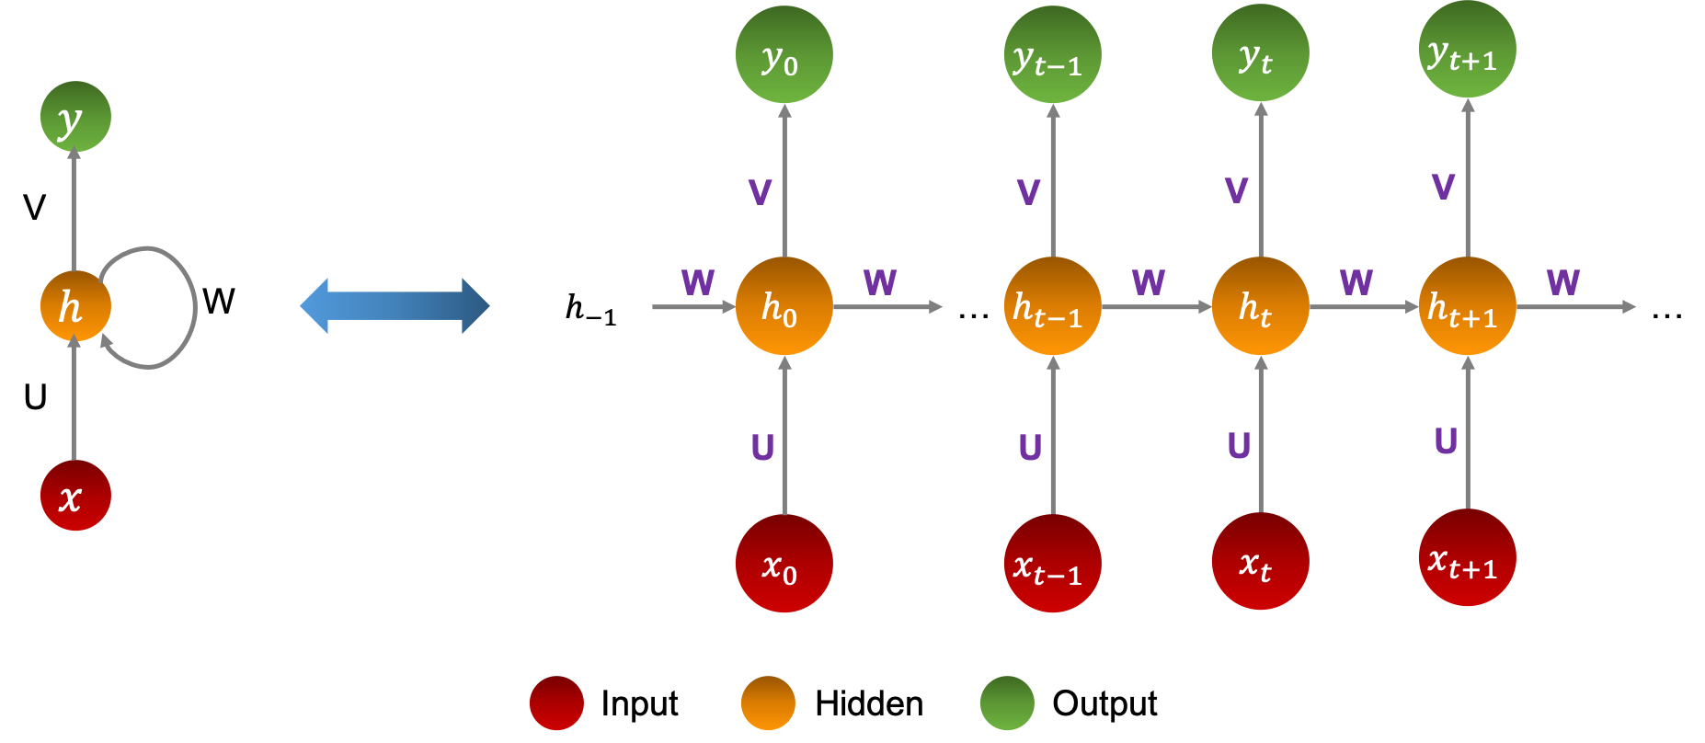

## Equations

The variables in the architecture are:

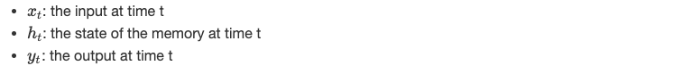

where:



h(−1)​ is randomly initialized, ϕ and ψ are non-linear functions, U, V, and W are parameters of the various linear regressions, preceding the nonlinear activations.  
It is important to note that they are **the same throughout the architecture**.

## Applications

Recurrent neural networks have significantly improved sequential models, in particular:

* NLP Tasks, Modeling and Text Generation
* Translation machine
* Voice recognition

We summarize the above applications in the following table:

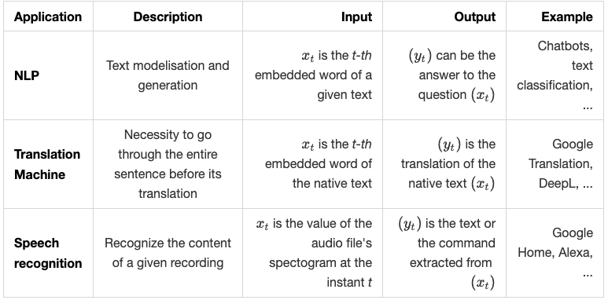

## Learning algorithm

As in classical neural networks, learning in the case of recurrent networks is done by optimizing a cost function with respect to U, V and W. In other words, we aim to find the best parameters that give the best prediction y^i, starting from the input xi​, of the real value yi​.

For this, we define an objective function called the loss function and denoted J which quantifies the distance between the real and the predicted values on the overall training set.

We minimize J following two major steps:

* **Forward Propagation**: we propagate the data through the network either in entirely or in batches, and we calculate the loss function on this batch which is nothing but the sum of the errors committed at the predicted output for the different rows.
* **Backward Propagation Through Time**: consists of calculating the gradients of the cost function with respect to the different parameters, then apply a descent algorithm to update them. It is called BPTT, since the gradients at each output depend both on the elements of the same instant and the state of the memory at the previous instant.

We iterate over the same process a number of times called epoch number. After defining the architecture, the learning algorithm is written as follows:

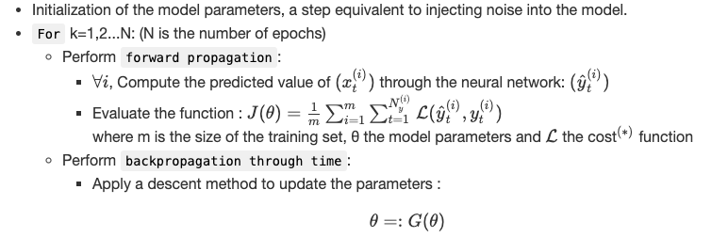

(∗) The cost function L evaluates the distances between the real and predicted value on a single point.

## Forward propagation

Let us consider the prediction of the output of a single sequence through the neural network.  
At each moment t, we compute:



Until reaching the end of the sequence.  
Again, the parameters U, W and V remain the **same** all along the neural network.  
When dealing with an m-row data set, repeating these operations separately for each line is very costly. Hence, we truncate the dataset in order to have sequences described in the same timeline, i.e:



We can use linear algebra to parallelize it as follows:

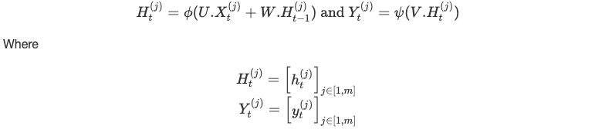

## Backpropagation Through Time

The backpropagation is the second step of the learning, which consists of injecting the errorcommitted in the prediction (forward) phase into the network and update its parameters to perform better on the next iteration. Hence, the optimization of the function J, usually through a descent method.

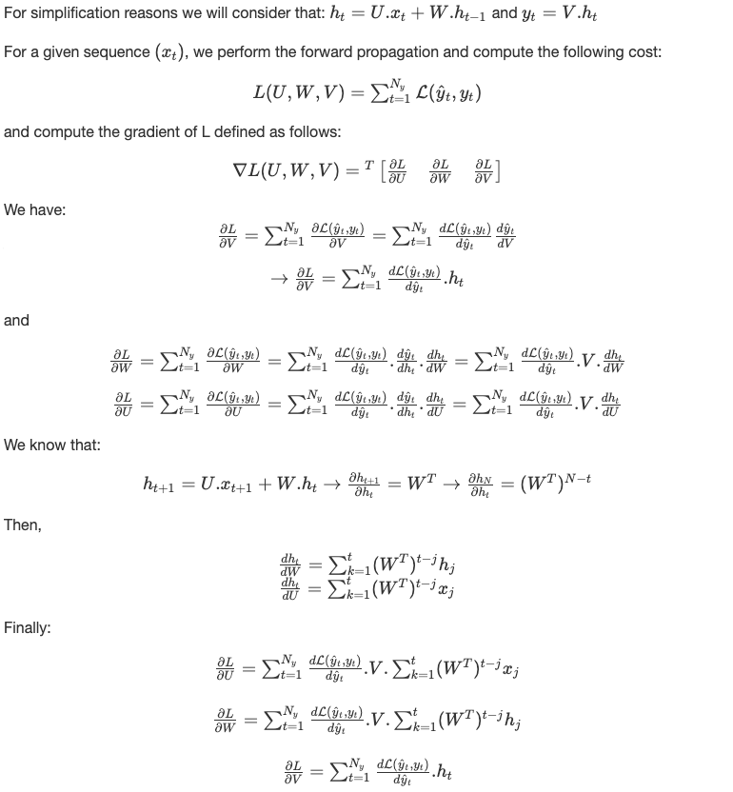

We can now apply a descend method as detailed in the previous section

## Memory problem

There are several fields where we are interested in predicting the evolution of a time series based on its history: music, finance, emotions…etc.  
The intrinsic recurrent networks described above, called ‘Vanilla’, suffer from a weak memory unable to take into account several elements of the past in the prediction of the future.

With this in mind, various extensions of the RNNs have been designed to trim the internal memory: bi-directional neural networks, LSTM cells, attention mechanisms…etc. Memory enlargement can be crucial in certain fields such as finance where one seeks to memorize as much history as possible in order to predict a financial series.

The learning phase in RNN might also suffer from gradient vanishing or gradient exploding problems since the gradient of the cost function includes the power of W which affects its memorizing capacity.

# 3. Different types of RNNs

There are several extensions for classic or ‘Vanilla’ recurrent neural networks, these extensions have been designed to increase the memory capacity of the network along with the features extraction capacity.  
The illustration below summarizes the different extensions:

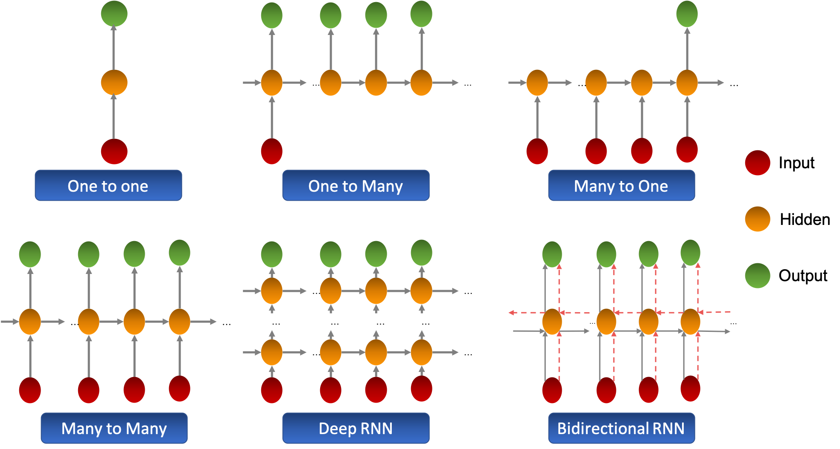

There exist other types of RNNs that have a specifically designed hidden layer which we will discuss in the next chapter.

# 4. Advanced types of cells

## Gated Recurrent Unit

GRU (Gated Recurrent Unit) cells allow the recurrent network to save more historical information for a better prediction. It introduces an update gate which determines the quantity of information to keep from the past as well as a reset gate which sets the quantity of information to forget.  
The graph bellow schematizes the GRU cell:

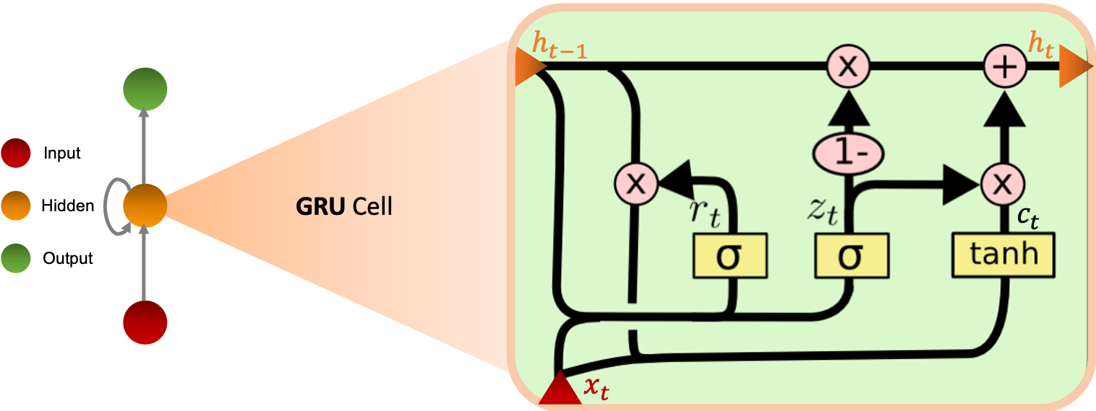

**Equations**We define the equations in the GRU cell as follows:

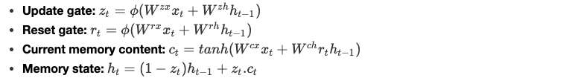

ϕ is a non-linear integer function and the parameters W are learned by the model.

## Long Short Term Memory

LSTMs (Long Short Term Memory) were also introduced to overcome the problem of short memory, they have 4 times more memory than Vanilla RNNs. This model uses the notion of gates and has three:

* Input gate i: controls the flow of incoming information.
* Forget gate f: Controls the amount of information from the previous memory state.
* Output gate o: controls the flow of outgoing information

The graph below shows the operation of the LSTM cell:

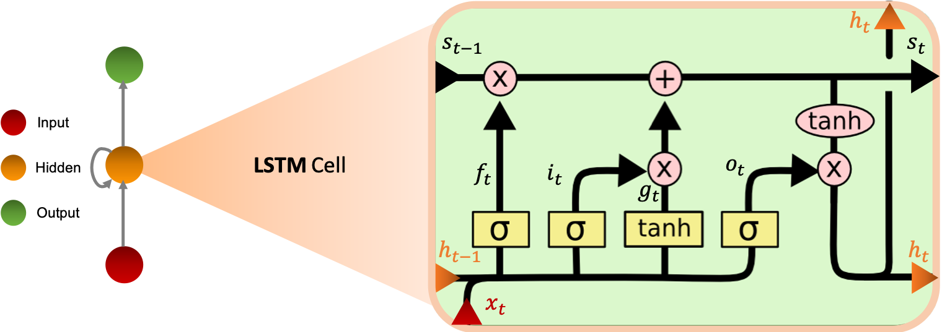

When the input and output doors are closed, activation is blocked in the memory cell.

**Equations**We define the equations in the LSTM cell as follows:

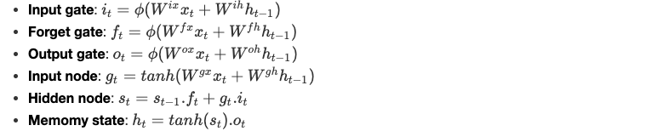

**Pros & Cons**We can summarize the advantages and disadvantages of LSTM cells in 4 main points:

* **Advantages**

+They are able to model long-term sequence dependencies.  
+They are more robust to the problem of short memory than ‘Vanilla’ RNNs since the definition of the internal memory is changed from:



* **Disadvantages**

+They increase the computing complexity compared to the RNN with the introduction of more parameters to learn.  
+The memory required is higher than the one of ‘Vanilla’ RNNs due to the presence of several memory cells.

# 5. Encoder & Decoder architecture

It is a sequential model consisting of two main parts:

* Encoder: the first part of the model processes the sequence and then returns at the end an encoding vector of the whole series called context vector which summarizes the information of the different inputs.
* Decoder: the context vector is then taken as the input to the decoder in order to make the predictions.

The diagram below illustrates the architecture of the model :

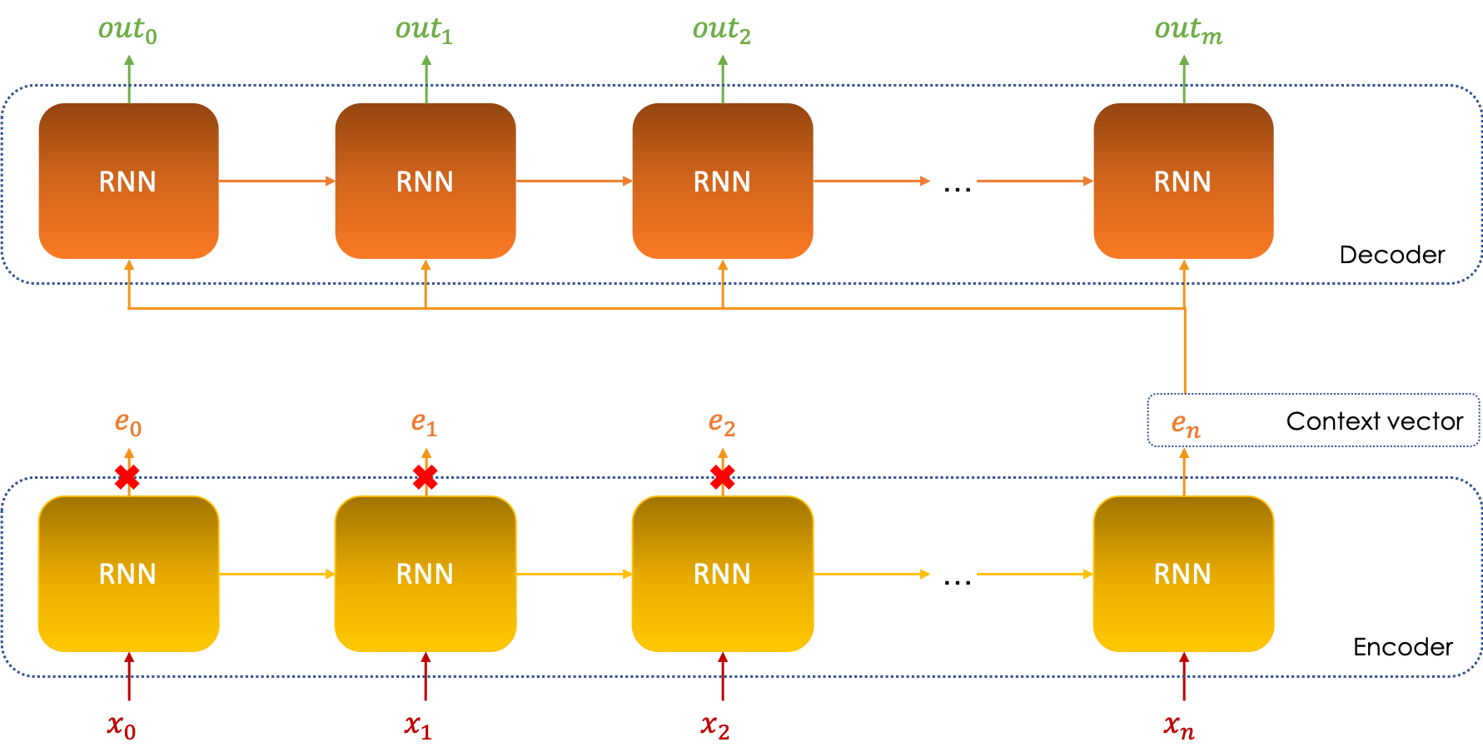

The encoder can be considered as a dimension reduction tool, matter of fact, the context vector en​ is nothing else than the encoding of the input vectors (in0​,in1​,…inn​), the sum of the sizes of these vectors is much larger than that of en, hence the notion of dimension reduction.

# 6. Attention mechanisms

Attention mechanisms were introduced to address the problem of memory limitation, and mainly answer the following two questions:

* What weight (importance) αj​ is given to each output ej​ of the encoder?
* How can we overcome the limited memory of the encoder in order to be able to ‘remember’ more of the encoding process?

The mechanism inserts itself between the encoder and the decoder and helps the decoder to significantly select the encoded inputs that are important for each step of the decoding process outi​ as follows:

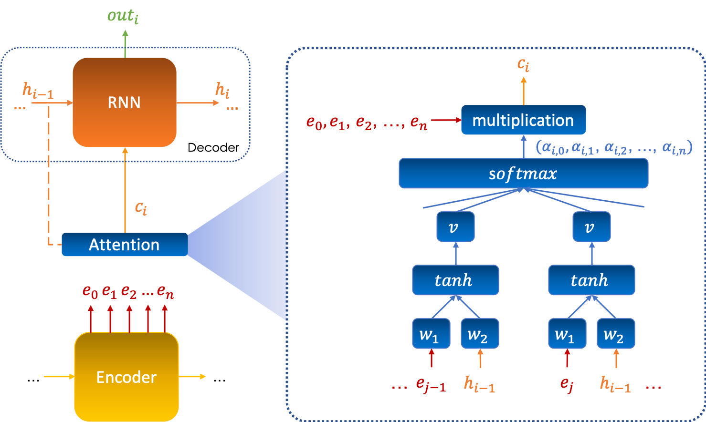

## Mathematical formalism

Keeping the same notation as before, we set αi,j​ as the attention given by the output i, denoted outi​, to the vector ej​.  
The attention is computed via a neural network which takes as inputs the vectors (e0​,e1​,…,en​) and the previous memory state h(i-1)​, it is given by:

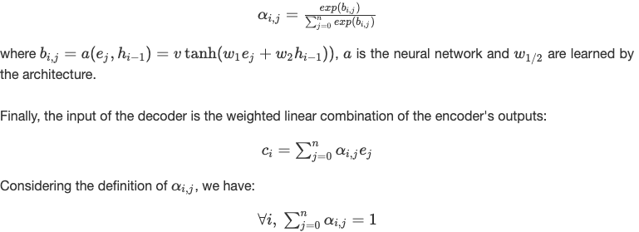

## Application: Translation Machine

The use of an attention mechanism makes it possible to visualize and interpret what the model is doing internally, especially at the time of prediction.  
For example, by plotting a 'heatmap' of the attention matrix of a translation system, we can see the words in the first language on which the model focuses to translate each word into the second language:

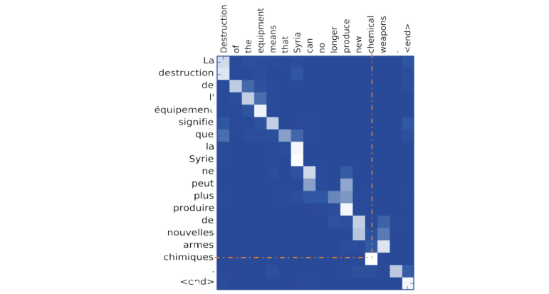

As illustrated above, when translating a word into English, the system focuses in particular on the corresponding French word.

## Overlay of LSTM & Attention Mechanism

It is relevant to combine the two methods to improve internal memory, since the first one allows more elements of the past to be taken into account and the second one chooses to pay careful attention to them at the time of prediction.  
The output ct of the attention mechanism is the new input of the LSTM cell, so the system of equations becomes as follows :

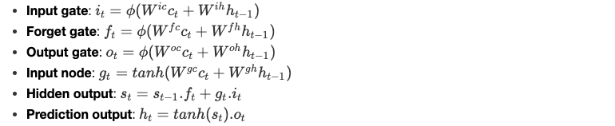

ϕ is a non-linear integer function and the parameters W are learned by the model.

# Conclusion

RNNs are a very powerful tool to deal with sequence data, they provide incredible memorizing capacities and are widely used in day-to-day life.  
They also have many extensions which enable to address various types of data-driven problems, more particularly the ones discussing times series.